1. **Introduction**



1. **Introduction**

:

* Platform functionalities include streaming songs and albums.
* Users can see what songs their friends are currently listening to.
* Users can check the online status of their friends.
* A built-in chat feature allows friends to interact on the platform.
* Admin capabilities include logging into the system.
* Admins can add songs, albums, and artists to the platform's catalogue.
* Reports for administrators are available on a weekly and monthly basis.
* Subscription options are available for users to purchase.
* Subscribers enjoy an ad-free music streaming experience.
* The platform enhances user engagement with its social and interactive features
* **Stream songs and albums** seamlessly with a user-friendly interface.
* **View friend activities**, including the songs your friends are currently listening to.
* **Check online status** to see which friends are active on the platform.
* **Chat functionality** allows friends to message each other directly within the platform.
* **Admin capabilities** include:
  + Logging into the admin dashboard.
  + Adding songs, albums, and artists to expand the platform's music library.
  + Generating detailed reports on a weekly or monthly basis for performance insights.
* **Subscription options** offer premium benefits, including:
  + An **ad-free music experience** for uninterrupted listening.
  + Exclusive content or features available only to subscribers.
* **Personalized recommendations** powered by user listening history and preferences.
* **Curated playlists** for different moods, genres, and occasions.
* **Customizable playlists**, allowing users to create and share their own music collections.
* **Search and discovery tools** to help users find new music, artists, or albums effortlessly.
* **Multi-device support** for a seamless experience across smartphones, tablets, and computers.
* **Offline mode** for premium users, enabling them to download songs and listen without an internet connection.
* **Social sharing features** to post favourite tracks or playlists on social media.
* **User profiles** where individuals can showcase their listening habits and favourite music.
* **Music analytics** to track stats like top-played songs and hours spent listening.
* **Dark mode** to enhance user experience during night-time or low-light listening.
* **Integration with smart devices**, such as speakers or wearables, for enhanced accessibility.
* **Parental controls** to filter explicit content and ensure a family-friendly experience.

**2. Project Profile**

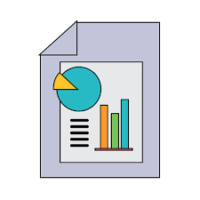

**2. Project Profile**

|  |  |
| --- | --- |
| **Details** | **Description** |
| Project Name | Audio streaming platform |
| Description | In this website user can listen to songs and albums and at the same time can able to see the songs what there friends can hear and also able to chat with them .  Admin can add and remove songs and also able to see the reports of the songs based on the songs and albums plated by the users. |
| Name of the Institute | C. B. Patel Computer College |
| Category | Mern Stack based Web Application |
| Front End Tool | React , TypeScript . |
| Back End Tool | MongoDB , NodeJS , ExpressJS . |
| Editors | Visual Studio |
| Designing Tool | Tailwind , CSS |
| Project Guide | Asst. Prof. Jagruti Joshi |
| Submitted By | Mihani Bhavesh Prakash  Tiwari Nishant Mukesh  Mehta Dhairya Ashvinkumar  Shukla Ujjwal Anand |
| Submitted To | C. B. Patel Computer College |

**3. Project Category**



**3. project category**

**Project Category: Social Audio Streaming Platform with Administrative Management**

* **Core Music Streaming Engine**
  + Ability to play songs and albums seamlessly
  + Robust and scalable streaming functionality
* **User-Centric Experience**
  + Intuitive user interface for effortless navigation
  + Real-time activity feed to see the songs friends are listening to
  + Online/offline status indicators for friends
  + Dynamic user profiles highlighting favorite tracks and listening habits
* **Social Interaction & Engagement**
  + Integrated chat functionality enabling users to communicate within the platform
  + Features that promote sharing of music experiences socially
  + Potential for future social features like playlist sharing and commenting
* **Administrative Control & Content Management**
  + Secure admin login for managing platform content
  + Capabilities to add and manage songs, albums, and artists efficiently
  + Dedicated admin panel to curate and update the music catalog
* **Analytics & Reporting**
  + Reporting tools providing insights on a weekly and monthly basis
  + Comprehensive metrics to track platform performance and user engagement
* **Subscription & Monetization**
  + Subscription models offering premium benefits, such as an ad-free experience
  + Seamless transactional integration for buying subscriptions
  + A focus on delivering uninterrupted high-quality music experiences for subscribers

• **Personalized Music Recommendations:**

* Use advanced algorithms to suggest songs, albums, and playlists tailored to each user’s listening history and preferences.
* Offer “discover weekly” or “daily mix” playlists that update automatically.

• **Collaborative Playlists:**

* Allow users to create and modify shared playlists with their friends.
* Introduce features where friends can vote on the next track during collaborative sessions.

• **Interactive Social Feed:**

* Develop a real-time activity feed that displays what songs friends are listening to, their comments, and likes.
* Integrate reactions or emoji responses for quick engagement.

• **Enhanced Chat and Group Messaging:**

* Expand the chat functionality to support group conversations around specific genres, artists, or playlists.
* Implement voice or video chat options during live listening sessions or events.

• **Live Listening Parties and Virtual Concerts:**

* Host synchronous listening sessions where users can tune in together, complete with live chat.
* Organize virtual concerts or Q&A sessions with artists to drive community participation.

• **Gamification and Rewards:**

* Reward users with points, badges, or leaderboards for engaging in activities such as daily logins, playlist creation, or inviting friends.
* Create challenges like “listening streaks” or trivia quizzes related to music genres and history.

• **User-Generated Content:**

* Enable reviews, song ratings, and comments so users can share their opinions and insights.
* Set up community forums or themed discussion boards for music lovers to debate and connect.

• **Social Media Integration:**

* Allow users to effortlessly share their favorite tracks, playlists, or concert experiences on platforms like Instagram, Twitter, or Facebook.
* Use social login options to simplify access and encourage wider sharing.

• **Push Notifications and Alerts:**

* Send targeted notifications about new releases, upcoming live events, or activities from friends.
* Provide custom alert settings so users can choose the type and frequency of notifications.

• **Interactive In-Stream Features:**

* Integrate live lyrics display with real-time annotations or fun facts about songs.
* Enable features like “song reactions” or polls during tracks to keep listeners interactive.

• **Augmented Reality (AR) and Visual Enhancements:**

* Offer AR experiences for album art that transforms into interactive visual stories when viewed through a mobile device.
* Create dynamic visualizers that respond to the mood and tempo of the music.

• **Voice Command Integration:**

* Incorporate voice control to allow users to search for music, switch playlists, or control volume hands-free, adding convenience and a modern edge.

• **Offline and Multi-Device Sync:**

* Allow premium users to download songs for offline listening.
* Ensure a seamless experience by syncing user profiles, playlists, and listening history across multiple devices

**4. Objectives**



**4. Objectives**

* Enable High-Quality Music Streaming:
  + Facilitate seamless playback of songs and albums for users to enjoy their favorite music.
* Promote Social Connectivity:
  + Allow users to see what songs their friends are listening to and check their online status.
  + Foster interaction and engagement through a built-in chat feature.
* Provide a User-Friendly Experience:
  + Deliver a smooth and intuitive platform for both casual listeners and premium subscribers.
* Empower Administrative Control:
  + Offer admin functionality to log in, add songs, albums, and artists to the platform.
  + Provide tools for administrators to manage content and monitor platform performance.
* Support Data-Driven Insights:
  + Generate weekly and monthly reports to analyze user engagement and platform activity.
* Implement Monetization Strategies:
  + Offer subscription plans to provide users with an ad-free experience.
  + Enhance user satisfaction by giving premium subscribers uninterrupted access to content.
* Create an Engaging and Interactive Community:
  + Encourage collaboration and connections among users through interactive features.
  + Build a platform that combines music with social interaction for a unique experience.
* Focus on Scalability and Growth:
  + Develop features that attract new users while retaining existing ones.
  + Ensure the platform is adaptable for future enhancements and upgrades
* Social Music Experience:
  + Users can see what songs their friends are listening to and interact through real-time chats, fostering a sense of community and shared enjoyment.
* Friend Activity and Online Status:
  + The ability to check friends' online status and their current listening habits makes the platform highly interactive and engaging.
* Admin-Friendly Content Management:
  + A robust admin panel allows easy addition and management of songs, albums, and artists, enabling dynamic content updates for users.
* Comprehensive Reporting Tools:
  + Weekly and monthly reports empower admins with actionable insights into platform performance and user activity.
* Ad-Free Subscription Model:
  + An attractive subscription plan offers users an uninterrupted, ad-free listening experience, enhancing satisfaction and loyalty.
* Interactive Community Building:
  + Integrated features such as social sharing, chats, and activity feeds create a space where users connect over shared musical interests.
* Future Scalability:
  + The platform is designed with social and subscription-based features, making it scalable for integrating additional functionalities like collaborative playlists or live events.
* All-in-One Functionality:
  + Combines music streaming with social interaction, offering more than just a place to listen to songs—it’s a hub for discovery, connection, and community.
* Customizable User Experience:
  + Personalized playlists, recommendations, and user profiles make the platform feel tailored and unique to each individual

**5. Environment Description**

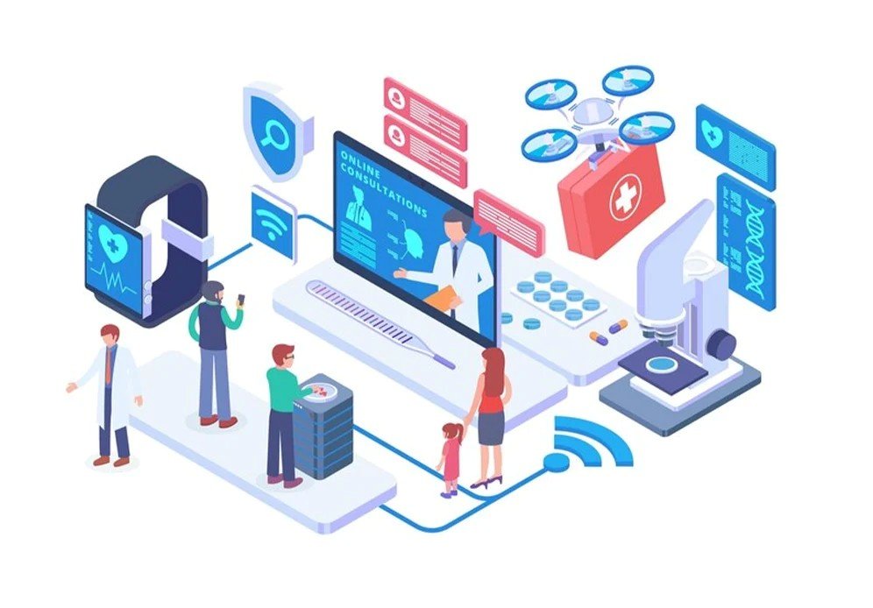

**5.1 Hardware and Software Requirement**

**5.2 Tools & Environment Used**

**5.1 H/W & S/W Requirements**

* The efficient hardware and software configuration required to run the system is as suggested below. The configuration suggested is adequate, the same functionality or higher configuration will always be better.
* **Hardware Requirement** :-
* **Processor :** Intel(R) Core(TM) i5-10210U CPU 2.11 GHz
* **RAM :** 8.00 GB
* **HDD :** < 512 GB Storage
* **Input Device :** Keyboard, Mouse.
* **Output Device :** Monitor, Printer.
* **Printer :** Any Compatible with OS
* Software Requirement :-
* **Operating System** : Windows 7 or above
* **Front end** : Visual Studio
* **Back end** : MongoDB Database , Cloudinary.

**5.2 Tools & Environment Used**

* REACT
* TYPESCRIPT
* TAILWIND
* CSS
* MongoDB
* ExpressJS
* NodeJS
* **React JS**

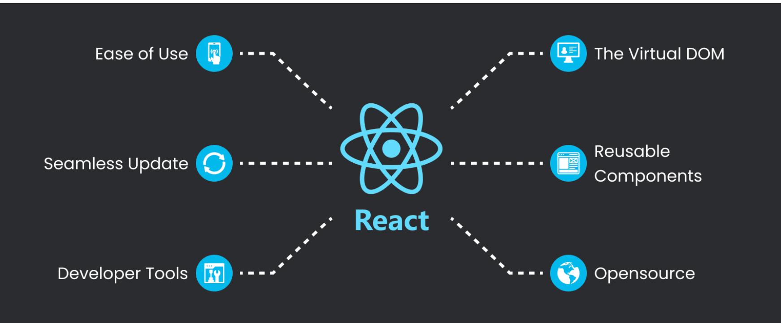

React.js is an open-source JavaScript library developed by Facebook (now Meta) that revolutionizes the way we build user interfaces for web applications. It focuses on creating highly dynamic and responsive UI components through a component-based architecture. Let’s delve deep into what makes React.js unique and powerful:

1. Component-Based Architecture

* Modularity: React allows you to break down your UI into encapsulated pieces called components. Each component manages its own state and logic and can be reused, making code more maintainable and scalable.
* Hierarchy: Components are organized in a tree-like structure. A single application can be built by nesting multiple components within one another. This decomposition encourages separation of concerns and simplifies complex UIs.
* Reusability: Once a component is built, it can be reused in various parts of the application or even in different projects. This speeds up development and ensures consistency across the UI.

2. The Virtual DOM

* Efficient Rendering: Instead of directly manipulating the browser’s Document Object Model (DOM), React uses a lightweight, in-memory representation called the Virtual DOM. When changes occur, React updates the Virtual DOM first, then efficiently calculates the minimal set of changes required to update the real DOM.
* Performance Benefits: This diffing algorithm minimizes expensive DOM operations, leading to faster updates and smoother user experiences, especially in applications with frequent UI changes.
* **3. JSX – JavaScript Syntax Extension**
* **Intuitive Code Structure:** JSX allows developers to write HTML-like syntax directly within JavaScript code. This makes it easier to visualize the UI structure and how components integrate with logic.
* **Enhanced Readability:** With JSX, the separation between logic and presentation becomes blurred in a positive way—it keeps the markup and the corresponding behavior in one place, improving code clarity.
* **Pre-Compilation:** JSX isn’t natively understood by browsers; it must be transpiled (using tools like Babel) into standard JavaScript, allowing for advanced optimizations and integration with modern JavaScript ecosystems.
* **4. State and Props Management**
* **State:** Components can maintain their internal state to track data that changes over time, such as user inputs or asynchronous data fetches. In class-based components, state is managed via the this.state object, while in functional components, React Hooks (such as useState) manage state.
* **Props:** “Properties” (or props) are read-only inputs passed from one component to another. They enable developers to customize and compose components dynamically.
* **Unidirectional Data Flow:** React enforces a top-down data flow (from parent to child components). This predictability simplifies debugging and makes state management more straightforward.
* **5. Lifecycle Methods and Hooks**
* **Lifecycle Methods (in Class Components):** React components have different lifecycle stages (mounting, updating, unmounting). Methods like componentDidMount, componentDidUpdate, and componentWillUnmount let you perform actions at specific points in a component’s lifecycle, such as fetching data or cleaning up resources.
* **Hooks (in Functional Components):** Introduced in React 16.8, Hooks provide a way to use state and lifecycle features without writing class components. Key Hooks include:
* useState for state management.
* useEffect for handling side effects (e.g., data fetching, subscriptions).
* useContext for accessing global data without prop drilling.
* Hooks promote cleaner, more functional, and readable code while also encouraging better separation of logic into custom hooks.
* **6. Ecosystem and Tooling**
* **React Developer Tools:** A browser extension that allows developers to inspect, debug, and profile React applications. It provides insights into component hierarchies, state, and performance optimizations.
* **Routing and State Management:** Although React focuses on the UI layer, it integrates seamlessly with libraries like React Router for client-side routing and state management libraries such as Redux, MobX, or the Context API for handling complex application states.
* **React Native:** Beyond web development, React’s principles extend to mobile app development with React Native. This framework allows you to build native mobile apps for iOS and Android using the same component-based approach.
* **7. Declarative Programming Paradigm**
* **Simplified UI Logic:** React’s declarative nature means that you describe what the UI should look like based on the current state. React handles the underlying process of updating the DOM, reducing the complexity of manual DOM manipulations.
* **Predictability and Maintenance:** Since components re-render based solely on state and props changes, the flow of data and UI updates becomes more predictable, aiding in debugging, testing, and long-term maintenance.
* **Conclusion**
* React.js is much more than just another JavaScript library—it offers a transformative approach to building modern, highly interactive web interfaces. Its blend of component-based architecture, efficient Virtual DOM management, intuitive JSX syntax, robust state management patterns, and a vast ecosystem of tools and libraries make it a top choice for developers worldwide.

By abstracting complex DOM operations and promoting a clear, modular design, React empowers developers to build scalable, maintainable, and high-performance applications. Whether you're developing a simple user interface or a complex real-time streaming platform, React’s flexible architecture and vibrant community support can help you deliver a polished user experience

* **TYPE SCRIPT**

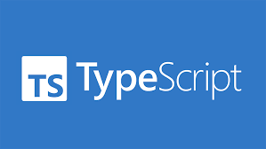

**What is TypeScript?**

* **Superset of JavaScript:** TypeScript is an enhancement over JavaScript, meaning every valid JavaScript is also a valid TypeScript. It extends JavaScript by introducing additional features that are not available in the standard language.
* **Purpose-Driven Development:** Its creation was aimed primarily at improving the development process for large-scale applications. TypeScript’s design addresses issues that often arise in complex projects, such as maintainability and scalability.

**2. Core Philosophy and Principles**

* **Static Type Checking:** Unlike JavaScript, which is dynamically typed, TypeScript adds an optional layer of static typing. This means that variables, function parameters, and return values can be defined with specific types. This allows potential errors to be caught during the development phase rather than at runtime.
* **Emphasis on Code Robustness:** The static type system encourages developers to think carefully about the structure of their code. This leads to more predictable behavior and reduces bugs, especially in complex applications with many interdependent components.
* **Improved Self-Documentation:** With explicit type annotations, code becomes clearer and easier to understand. This facilitates better communication within development teams and simplifies onboarding processes for new team members.

**3. Compilation and Tooling**

* **Transpilation Process:** TypeScript is not executed by browsers directly; it must first be transpiled (or compiled) into standard JavaScript. This process checks for type errors and translates TypeScript’s advanced features into backward-compatible JavaScript code.
* **Configuration and Flexibility:** The transpilation is governed by a configuration file that allows developers to specify various compiler options. This ensures that the output adheres to the required JavaScript standards and fits seamlessly into existing build workflows.
* **Enhanced Development Tools:** Modern integrated development environments (IDEs) like Visual Studio Code leverage TypeScript’s detailed type information to provide advanced features such as auto-completion, intelligent code navigation, and powerful refactoring tools. This leads to an overall improvement in developer productivity.

**4. Object-Oriented Programming and Structure**

* **Advanced Object-Oriented Features:** TypeScript was designed with support for object-oriented programming in mind. It embraces class-based programming, allowing developers to use concepts like inheritance, interfaces, and abstract classes, which make the construction of large applications more modular and organized.
* **Structured Code Organization:** By promoting a disciplined approach to structuring code, TypeScript helps prevent common pitfalls of loosely typed languages. This structured approach is invaluable when multiple developers work on the same codebase, as it leads to consistent and maintainable code over time.

**5. Type Inference and Flexibility**

* **Dynamic vs. Static Elements:** While TypeScript encourages explicit type definitions, it also features type inference. This means that even when types are not explicitly declared, the TypeScript compiler can often deduce them from the context, offering a balance between flexibility and safety.
* **Optional Typing Paradigm:** Developers have the freedom to adopt stricter type annotations as needed. This enables teams to gradually migrate existing JavaScript projects to TypeScript, incrementally enforcing stricter type checks without having to refactor the entire codebase immediately.

**6. Ecosystem and Community Support**

* **Broad Adoption in Industry:** TypeScript has seen widespread adoption across many projects and organizations. Major frameworks and libraries, particularly those in the frontend space (such as Angular, React, and Vue), offer first-class support for TypeScript, enhancing its credibility and reliability.
* **Growing Developer Community:** With an active open-source community backing it, TypeScript continues to evolve with contributions from developers worldwide. This community-driven development ensures that TypeScript remains up-to-date with industry needs and integrates well with the latest tools and standards.
* **Rich Ecosystem of Libraries:** The extensive ecosystem means that many third-party libraries include TypeScript declaration files or are written in TypeScript themselves. This results in a more seamless integration between various parts of a project and helps maintain consistency across codebases.

**7. Advantages in Large-Scale Applications**

* **Enhanced Maintainability:** As applications grow in complexity, the use of static types helps prevent bugs that can be hard to trace in dynamic languages. This proactive error checking and enforced consistency significantly reduce maintenance overhead.
* **Facilitated Refactoring:** The clarity offered by type annotations and the structured nature of TypeScript make code refactoring safer and more straightforward. Developers can update or extend features with confidence, knowing that many potential issues will be flagged during compilation.
* **Streamlined Collaboration:** In team environments, the explicitness of TypeScript serves as both documentation and a contract between different parts of the application. This clarity reduces misunderstandings and ensures that all team members adhere to the same design principles.

**8. Challenges and Considerations**

* **Learning Curve:** Transitioning from JavaScript to a typed system requires a shift in mindset. Developers need to learn new concepts and adjust to a more disciplined approach to coding, which can be challenging initially.
* **Initial Overhead:** For smaller projects or prototypes, the additional step of writing type annotations and managing a compilation process might seem burdensome. However, the long-term benefits in larger, more complex systems typically outweigh these early costs.
* **Integration Lifestyle:** While many libraries support TypeScript, there might be compatibility issues with some JavaScript libraries that have incomplete type definitions. This requires attention and sometimes the writing of custom type definitions to ensure smooth integration.

**9. Conclusion**

TypeScript represents a significant evolution in the world of web development by marrying the flexibility of JavaScript with the robustness of static typing. It offers a better development experience through improved tooling, clearer code structure, and early error detection, all of which culminate in projects that are easier to maintain and scale. Even though there is a learning curve and initial overhead, the advantages it brings to large, collaborative projects make it an invaluable tool in modern software development

* **A logo with text on it

  AI-generated content may be incorrect.Tailwind CSS**

Tailwind CSS is a modern, utility-first CSS framework that reimagines the way you style web applications. Here’s an in-depth explanation of its features, philosophy, and benefits—all without including any code examples:

**1. Utility-First Philosophy**

* **Atomic Classes:** Tailwind CSS is based on the idea of using small, single-purpose classes that apply one specific style at a time. Instead of writing custom CSS selectors, you compose your design by combining these utility classes directly in your markup.
* **Encourages Consistency:** By building interfaces with pre-defined utility classes, you inherently promote design consistency. Your spacing, colors, and typographic scales remain uniform because you’re reusing the same class options throughout your project.
* **Low-Level Styling Tools:** Rather than offering pre-designed components, Tailwind gives you low-level building blocks. This means you're not locked into a design style; you have the freedom to craft unique interfaces by piecing together the utilities that best match your vision.

**2. Customization and Configurability**

* **Highly Configurable:** Tailwind CSS includes a configuration file that enables you to tailor the framework to your project's needs. You can redefine design tokens such as colors, fonts, spacing, and responsive breakpoints. This flexibility makes it easy to align with your brand’s identity.
* **Extensible with Plugins:** The framework supports a plugin architecture, allowing you to extend its capabilities. Whether you need new utilities or to integrate with design system components, plugins can help you maintain a clean and modular approach to styling.
* **Adaptive to Project Needs:** Because you configure Tailwind to match your design system, it scales effectively regardless of the project's size. Whether you’re prototyping a small component or building a large-scale application, Tailwind offers a unified approach to styling across the board.

**3. Performance and Optimization**

* **Efficient Production Builds:** One of Tailwind’s significant advantages is its ability to purge unused styles automatically. During the build process, it analyzes your markup and removes any classes you are not using, resulting in minimal CSS file sizes that enhance page load speed.
* **Consistency in Responsive Design:** Tailwind CSS comes with built-in support for responsive design. Its utility classes include configurable breakpoints that make it straightforward to build layouts that adapt effortlessly to different screen sizes, ensuring a seamless experience across devices.
* **Reduced Custom CSS Overhead:** By leveraging utility classes, developers usually write less custom CSS. This reduction in bespoke styles not only improves the maintainability of the codebase but also helps avoid conflicts and specificity issues common in traditional CSS development.

**4. Developer Experience**

* **Streamlined Workflow:** With Tailwind, styling becomes a matter of marking up HTML rather than switching back and forth between HTML and separate CSS files. This integration can speed up the development process, making it easier and faster to see and adjust your design.
* **Enhanced Readability and Maintainability:** When developers read through the markup, they encounter a straightforward list of utilities that describe the styling of an element. This clarity reduces ambiguity compared to navigating through a separate stylesheet, and makes it easier for teams to understand and maintain the design.
* **Focus on Design Iteration:** The granular control offered by utility classes allows for rapid prototyping and iterative design changes. Instead of wrestling with complex overrides or specificity wars, you can simply adjust or add a utility class to see a visual change immediately.
* **Collaboration-Friendly:** Since Tailwind enforces a consistent approach to applying styles, it becomes easier for multiple developers to work together on the same project. New team members can quickly learn the available utility classes and understand how components are styled, reducing onboarding time.

**5. Ecosystem and Community**

* **Growing Popularity:** Tailwind CSS has developed a robust and active community. This popularity means plenty of resources, from comprehensive documentation to community-driven components, themes, and tutorials that can help you overcome challenges and learn best practices.
* **Integration with Modern Frameworks:** The design pattern of Tailwind CSS fits naturally with modern JavaScript frameworks like React, Vue, and Angular. Developers appreciate how easy it is to integrate utility-first styling into component-driven architectures, further boosting its adoption across various projects.
* **Vibrant Ecosystem:** Beyond the core framework, there are complementary tools and extensions designed to enhance the Tailwind experience. These range from UI kits and component libraries to build tools that integrate seamlessly into existing workflows, helping maintain code consistency and accelerate development.

**6. Design System and Scalability**

* **Building Scalable Design Systems:** Tailwind CSS facilitates the creation of comprehensive design systems. With its configuration file, you can set standardized values for colors, fonts, spacing, and more—ensuring that your design system scales across your application without drifting into inconsistent styles.
* **Flexibility without Fragmentation:** While utility-first classes give you freedom, they also guide you to follow a consistent pattern across your codebase. This balance prevents style fragmentation and makes it easier to enforce guidelines across a team or organization.
* **MongoDB**

MongoDB is a popular, open-source, NoSQL database renowned for its flexibility, scalability, and developer-friendly nature. It deviates significantly from traditional relational databases by embracing a document-oriented data model. Here’s an in-depth look at its core principles, architecture, functionality, and ecosystem:

**1. Document-Oriented Data Model**

* **JSON-like Documents:** At the heart of MongoDB is its use of documents that resemble JSON objects. Internally, these documents are stored in a binary representation called BSON (Binary JSON). This format supports a rich set of data types beyond the basic JSON types, including dates and binary data.
* **Dynamic Schema:** Unlike relational databases that require a strict schema, MongoDB’s schema-less design allows each document within a collection to have its own structure. Developers can store diverse documents together, providing unparalleled flexibility when dealing with evolving data models.
* **Collections Instead of Tables:** In MongoDB, documents are grouped into collections, which are the equivalent of tables in relational databases. A collection provides a way to organize documents that share common attributes, yet with the freedom to vary in structure.

**2. Scalability and Performance**

* **Horizontal Scaling with Sharding:** One of MongoDB’s key strengths is its built-in support for sharding. Sharding divides the data across multiple servers, known as shards, making it possible to distribute load and handle massive amounts of data. This horizontal scaling approach allows for near-linear performance improvements as the system grows.
* **High Performance:** The document-based model and the fact that MongoDB stores related information together in a single document often result in fewer joins and more efficient data retrieval. Its in-memory computing and efficient indexing strategies contribute to its high-speed performance, even under heavy loads.
* **Indexing Capabilities:** MongoDB supports a variety of index types, including single field, compound, geospatial, and text indexes. These indexes improve query performance by allowing the database engine to swiftly locate and retrieve the desired documents.

**3. Replication and Data Redundancy**

* **Replica Sets for High Availability:** To ensure data redundancy and fault tolerance, MongoDB employs replica sets. A replica set is a group of MongoDB servers that maintain the same data. One node is designated as the primary node where write operations occur, while secondary nodes replicate the data from the primary. If the primary fails, an automatic election process promotes a secondary to the role of primary, keeping the database available.
* **Automatic Failover:** This built-in mechanism means that MongoDB can continue operating even in the face of hardware failures or network issues. The automatic failover is critical for applications that require high availability and minimal downtime.

**4. Powerful Query and Aggregation Frameworks**

* **Rich Query Language:** MongoDB’s query language is intuitive and flexible. It allows filtering, projection, and sorting of documents using a syntax that resembles JSON, making it accessible for developers familiar with the language.
* **Aggregation Pipeline:** For advanced data processing, MongoDB provides an aggregation framework. The aggregation pipeline conceptually transforms documents in stages—filtering, grouping, sorting, and reshaping data. This framework is particularly useful for building complex analytics and real-time reporting features directly within the database.

**5. Schema Design and Flexibility**

* **Embedded vs. Referenced Documents:** MongoDB’s flexible schema enables different data modeling techniques. Developers can embed related data within a single document for faster read operations, or reference separate documents across collections for normalized data. The choice depends on access patterns and performance needs.
* **Iterative Development:** The lack of a strict schema allows teams to quickly adapt the data model as requirements evolve. This agility is particularly advantageous in agile development environments where rapid prototyping and frequent changes are common.

**6. Security Features**

* **Robust Access Control:** MongoDB offers granular control over access to data through role-based access control (RBAC). Administrators can define roles with specific permissions, ensuring that users and applications have only the access they require.
* **Encryption and Auditing:** Security is further enhanced with features like data encryption (both at rest and in transit) and auditing capabilities. These features help secure sensitive data and ensure compliance with various regulatory standards.
* **Authentication Mechanisms:** Multiple authentication methods are supported, such as username/password, LDAP integration, and Kerberos. This variety allows MongoDB to fit into various enterprise security environments.
* MongoDB stands as a versatile, high-performance NoSQL database that adapts to modern application requirements. Its document-oriented model frees developers from the rigid constraints of relational schemas, fostering agile development and rapid iteration. With its powerful aggregation framework, robust indexing, high availability features, and an ever-expanding ecosystem, MongoDB is well-suited for a wide range of applications—from real-time analytics to scalable web and mobile backends.
* If you’re interested in exploring further, topics such as best practices in schema design, strategies for sharding and replication, or case studies of MongoDB in enterprise environments could provide additional valuable insights.
* 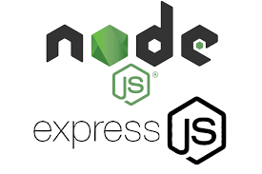**NODE JS and EXPRESS JS**

**Node.js**

* **JavaScript Runtime Environment:** Node.js is a runtime environment that allows you to execute JavaScript code on the server side, outside of a browser. Built on Google’s V8 JavaScript engine, it brings the efficiency and performance of compiled JavaScript into server-side application development.
* **Event-Driven and Non-Blocking I/O:** Designed with an asynchronous, event-driven architecture, Node.js excels at handling numerous connections concurrently. It uses a single-threaded event loop to manage I/O operations, enabling it to handle tasks like network requests and file system operations without blocking the rest of the process.
* **High Performance and Scalability:** The non-blocking I/O model and efficient handling of asynchronous events make Node.js particularly suitable for building scalable network applications. Whether you're constructing real-time chat applications, streaming services, or RESTful APIs, Node’s architecture offers the performance required by modern, high-traffic applications.
* **Rich Ecosystem and Packages:** Node.js is accompanied by an extensive ecosystem of libraries and modules available via npm (Node Package Manager). This community-driven repository provides developers with ready-made solutions to common problems—a benefit that accelerates development and enhances functionality.
* **Versatility in Use Cases:** Beyond web servers, Node.js is used for command-line tools, microservices, and even desktop applications through frameworks like Electron. Its versatility stems from the fact that it unifies backend operations with the language many developers already know for client-side work.

**Express.js**

* **Minimalist Web Framework on Top of Node.js:** Express.js is a fast, unopinionated framework that builds on the capabilities of Node.js. . Its primary goal is to simplify the process of creating web servers and RESTful APIs by providing a robust set of features for handling HTTP requests and responses.
* **Streamlined Routing and Middleware:** One of Express.js’s standout features is its intuitive routing system, allowing you to define various endpoints and HTTP methods with ease. By using middleware—functions that process requests before they reach your final route handler—Express permits layered handling of tasks such as logging, authentication, validation, and error management. This modular approach encourages clean code and separation of concerns.
* **Facilitates Rapid Development:** Express abstracts many of the lower-level details involved in managing HTTP connections that you’d otherwise have to code directly in Node’s HTTP module. This abstraction not only reduces boilerplate code but also speeds up development, making Express an ideal choice for prototyping and production-quality applications.
* **Flexibility Without Constraints:** True to its minimalist philosophy, Express doesn’t impose any rigid design patterns or directory structures. Instead, it offers the freedom to structure your application as you see fit, which is particularly beneficial in projects where flexibility and rapid iteration are key.
* **Integration with Front-End Technologies:** Express meshes well with modern front-end frameworks and templating engines. Whether you’re building a Single Page Application (SPA) or a traditional multi-page setup, Express can serve dynamic content as well as static files, forging a smooth connection between front-end and back-end functionalities.

**How They Complement Each Other**

* **Unified Development Environment:** Node.js provides the runtime environment that executes JavaScript on the server, while Express.js offers a higher-level framework that leverages Node’s capabilities to build web applications quickly. Together, they enable developers to write both server-side logic and web API endpoints in JavaScript, ensuring a consistent development experience.
* **Asynchronous Strengths:** Express takes full advantage of Node.js’s asynchronous processing by incorporating middleware that handles tasks in a non-blocking manner. This synergy allows applications built on this stack to manage multiple operations concurrently without sacrificing performance.
* **Robust Ecosystem:** The combination of Node.js’s npm ecosystem and Express.js’s simplicity fosters an environment where a vast array of plugins and middleware options are readily available. This ecosystem promotes rapid innovation, offering ready-to-integrate solutions for tasks like authentication, security, session management, and more.
* **Scalability for Modern Applications:** Many modern applications—ranging from API backends to real-time collaborative tools—rely on the scalability provided by Node’s event-driven architecture and the streamlined routing of Express. This makes the duo a popular choice for startups and enterprise-level systems alike.

**Conclusion**

**Node.js** and **Express.js** together empower developers to build high-performance, scalable, and maintainable web applications. Node.js lays the foundation with its efficient, event-driven runtime environment, while Express.js layers on top with its minimalist yet powerful approach to web application development. Their integration has not only popularized a unified JavaScript stack for both server and client development but also laid the groundwork for countless innovative applications in today’s digital landscape

* **Shad CN**

In the evolving landscape of web development, the quest for flexible, accessible, and highly customizable UI components remains paramount. **ShadCN** rises to this challenge by offering an innovative approach to building user interfaces that are both developer-friendly and aesthetically compelling. Let’s dive deep into what ShadCN is all about and examine its core features, benefits, and practical applications.

**What is ShadCN?**

ShadCN is an open-source UI library that blends powerful design principles with modern development practices. It is built on two key foundations:

* **Radix UI Primitives:** This ensures that the components have robust accessibility features, making them usable by everyone.
* **Tailwind CSS:** ShadCN leverages Tailwind CSS for styling, which means each component can be easily tailored to fit the unique look and feel of your project.

By merging these technologies, ShadCN delivers UI components that are not only beautiful but also function seamlessly across various devices and platforms.

**Core Features of ShadCN**

ShadCN offers a range of features designed to enhance the developer experience while prioritizing user accessibility:

* **Accessibility-First Design:**
  + Ensures components adhere to accessibility standards.
  + Promotes the creation of inclusive user interfaces.
* **Tailwind CSS Integration:**
  + Provides extensive styling customization.
  + Allows rapid adaptation to brand-specific designs and unique project requirements.
* **Modular and Flexible Architecture:**
  + Components can be integrated individually, reducing bloat in your project.
  + Encourages a reusable design system that scales with your application.
* **Zero-Fuss Setup:**
  + Developers can quickly incorporate components without the need for elaborate boilerplate setups.
  + Eliminates many of the usual friction points encountered during integration.

**Benefits of Using ShadCN**

ShadCN is engineered to address common pain points in UI development. Some of the key benefits include:

* **Time Efficiency:**
  + Pre-built components help reduce development time.
  + Allows developers to focus on core functionality rather than reinventing basic UI elements.
* **Enhanced User Experience:**
  + Accessible and responsive components contribute to a smoother and more inclusive user journey.
  + Consistency across UI elements results in a cohesive look and feel.
* **High Customizability:**
  + Tailwind CSS provides granular control over styling.
  + Adapt components to fit any design system without compromising on functionality or accessibility.
* **Community and Ecosystem:**
  + Growing support from an active community of developers.
  + Continuous improvements and updates based on collaborative feedback and real-world usage.

**Practical Applications in Real-World Projects**

Today's web applications demand rapid development cycles combined with high-quality interactive experiences. ShadCN has proven its versatility in various scenarios:

* **E-Commerce Platforms:**
  + Use ShadCN's components to build dynamic and user-friendly online stores.
  + Create an intuitive shopping experience with accessible navigation and responsive elements.
* **Administrative Dashboards:**
  + Implement comprehensive analytics panels with a clean, modern interface.
  + Ensure that complex data operations are presented in a user-accessible manner.
* **General Web Applications:**
  + Develop engaging websites and apps quickly without sacrificing quality.
  + Promote consistency across different pages and features, ensuring a unified user experience.
* **Prototyping and MVPs:**
  + Quickly turn concepts into working prototypes.
  + Utilize customizable components to refine ideas before scaling solutions.

**ShadCN in Your Developer Workflow**

Integrating ShadCN into your project can significantly enhance both the development process and the final product. Consider the following aspects:

* **Streamlined Collaboration:**
  + A consistent set of UI components helps teams stay aligned.
  + Shared components reduce the likelihood of design inconsistencies.
* **Focus on Innovation:**
  + With the basic building blocks in place, development teams can devote more time to unique, project-specific challenges.
  + The ready-to-use components allow room for creativity in higher-level functionalities.
* **Long-Term Scalability:**
  + As projects grow, the modular nature of ShadCN components simplifies ongoing maintenance.
  + Future enhancements and additional features can be integrated seamlessly.

**Conclusion**

ShadCN represents a modern and thoughtful approach to UI development. By embracing the principles of accessibility, customizability, and ease of integration, it empowers developers to create robust, clean, and user-centric interfaces in no time.

**Key takeaways:**

* **Accessibility:** ShadCN leverages Radix UI to build components that everyone can use.
* **Customization:** Thanks to Tailwind CSS, every component can reflect your specific design needs.
* **Efficiency:** Rapid integration and modular design speed up development while ensuring consistency.
* **Versatility:** Whether you’re working on e-commerce, dashboards, or innovative web applications, ShadCN offers the tools to bring your vision to life.

By considering ShadCN for your next project, you’re not only adopting a set of UI components—you’re embracing a philosophy of modern, inclusive, and efficient design that bridges the gap between creative vision and technological implementation.

* **Clerk**

**Clerk Authentication and Management: Streamlining Secure User Experiences**

In today’s digital age, ensuring a seamless, secure, and user-friendly authentication process is paramount. Clerk has emerged as a modern solution dedicated to simplifying how developers and businesses handle user identity, authentication, and management. This blog dives deep into the world of Clerk, its core features, benefits, and its transformative impact on application security and user experience.

**What is Clerk?**

Clerk is a comprehensive authentication and user management service built to address the modern needs of web and mobile applications. It provides pre-built, customizable components and streamlined workflows that help developers implement secure sign-in, sign-up, and overall user management with ease.

**Key aspects include:**

* **Out-of-the-Box Authentication Flows:** Clerk delivers ready-to-use UI components that cover everything from registration and login to password recovery.
* **Comprehensive User Management:** Beyond authentication, Clerk provides tools for managing user sessions, profiles, and roles, ensuring you have complete control over user data.
* **Focus on Security:** Emphasizes best practices like multi-factor authentication, secure session management, and token-based authorization, making your applications robust against common security threats.

**Core Features and Benefits of Clerk**

Clerk revolutionizes how developers achieve secure and efficient authentication. Here are the main features, distilled into key points:

* **Enhanced User Onboarding:**
  + **Seamless Registration:** Pre-designed flows ensure that new users can quickly and easily create accounts.
  + **User-Friendly Login:** Sign-in processes are optimized for speed and security, reducing friction for your users.
* **Multiple Authentication Methods:**
  + **Traditional and Passwordless Options:** Supports email/password combinations along with modern passwordless techniques.
  + **Social Logins:** Easily integrate popular platforms (e.g., Google, Facebook) to offer alternative sign-in options.
* **Advanced Security Measures:**
  + **Multi-Factor Authentication (MFA):** Adds an extra layer of security, significantly reducing the risk of unauthorized access.
  + **Secure Session Management:** Uses sophisticated token strategies to manage user sessions and safeguard against token theft.
* **Customizable User Interface:**
  + **Pre-Built UI Kits:** Save developers time with components that are not only secure but also visually consistent.
  + **Design Flexibility:** Tailor the look and feel of authentication flows to match your brand without compromising on functionality.
* **Robust User Management Tools:**
  + **Profile Management:** Provide users with control over their information while maintaining strict security standards.
  + **Role-Based Access Control:** Easily assign roles and permissions to different user groups, enabling fine-grained access management within your applications.
* **Developer-Centric Experience:**
  + **Quick Integration:** Streamlined onboarding procedures let you add authentication to your app rapidly.
  + **Clear Documentation:** Comprehensive guides and best practices that simplify configuration and ongoing management.
  + **Scalability:** Designed to grow with your application, supporting everything from small projects to enterprise-level systems.

**How Clerk Addresses Common Authentication Challenges**

Authentication has always been a challenging component of modern web development. Clerk tackles these issues with a fresh, user-centered approach:

* **Complexity Reduction:**
  + **Single Source of Truth:** Consolidate authentication and user management in one service to minimize integration headaches.
  + **Outsourcing the Heavy Lifting:** Delegate the security and reliability challenges to Clerk, freeing developers to focus on core business logic.
* **User Experience Optimization:**
  + **Frictionless Processes:** Streamlined workflows reduce user drop-off during sign-up and authentication.
  + **Responsive Design:** Components that work well on desktop and mobile, ensuring a consistent experience across devices.
* **Streamlined Administration:**
  + **Centralized Dashboard:** Monitor user activity, manage sessions, and control access all within an intuitive interface.
  + **Automated Maintenance:** Updates and security patches are managed continuously, keeping your software up-to-date with minimal intervention.

**Practical Applications: Where Clerk Shines**

Clerk isn’t just a theoretical solution—it’s designed for the real world, addressing genuine needs across various industries:

* **E-Commerce Platforms:**
  + **Secure Shopper Accounts:** Protect sensitive user information while ensuring a hassle-free checkout experience.
  + **Personalized Experiences:** Use profile data effectively to tailor product recommendations and promotions.
* **Software as a Service (SaaS):**
  + **Scalable Access Management:** As your user base grows, manage access levels and subscriptions effortlessly.
  + **Enterprise Security:** Implement strict security protocols suitable for business-critical applications.
* **Social and Community Platforms:**
  + **User Engagement:** Smooth onboarding and persistent sessions help keep users engaged and returning.
  + **Role-Sensitive Communities:** Differentiate access between regular users, moderators, and administrators with ease.
* **Internal Tools and Dashboards:**
  + **Enhanced Security for Sensitive Data:** Ensure that only authorized users can access internal systems and dashboards.
  + **Simplified User Management:** Integrate single sign-on and permission-based access tailored to organizational hierarchies.

**Architectural Considerations**

Understanding Clerk’s architectural approach provides insight into how it maintains high security and performance:

* **Token-Based Authentication:**
  + **JWT and Refresh Tokens:** Use stateless authentication tokens to manage sessions without storing sensitive data server-side.
  + **Expiration Control:** Tokens are rigorously managed to balance security and user convenience.
* **Backend Integration:**
  + **API-Driven Management:** Clerk integrates seamlessly with backend services, making it easy to sync with databases and other infrastructure.
  + **Event-Driven Updates:** Real-time management features keep your system up-to-date as users sign up, log in, or change their profiles.
* **Event Logging and Monitoring:**
  + **Audit Trails:** Built-in logging tracks user activity for added oversight and regulatory compliance.
  + **Performance Monitoring:** Continuous tracking ensures that authentication processes remain fast and efficient, even under high load.

**The Future of Authentication and User Management**

As applications continue to evolve, so do the challenges associated with authentication. Clerk is at the forefront of this evolution by offering:

* **Adaptive Security Measures:** The integration of AI-driven insights to adapt to new security threats in real time.
* **Continuous Integration:** Regular updates that incorporate the latest advancements in security protocols and user experience design.
* **Holistic User Views:** Future enhancements promise even deeper integration with analytics and user behavior tracking to further personalize and secure the user journey.

**Conclusion**

Clerk offers a modern, secure, and developer-friendly solution for all your authentication and user management needs. Its combination of ready-to-use UI flows, robust security practices, and comprehensive management tools makes it an ideal choice for anyone looking to streamline user experiences while minimizing implementation complexity.

**Key Takeaways:**

* **Integrated Authentication and Management:** Consolidates many facets of user identity under one roof.
* **Enhanced Security:** Delivers built-in measures such as MFA, token management, and secure session tracking.
* **Developer Friendliness:** Simplifies integration and provides clear documentation and customization options.
* **Cloudinary**

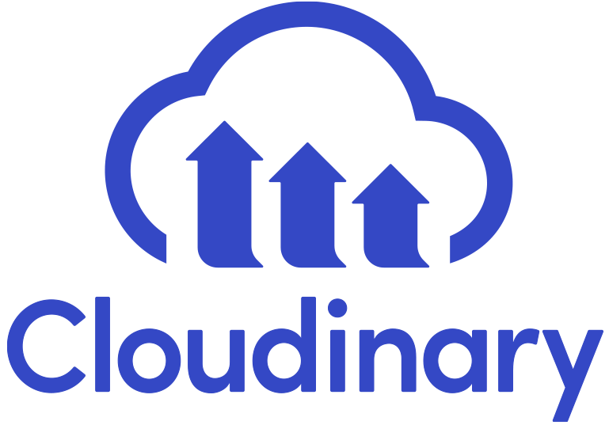

**Cloudinary: Revolutionizing Visual Content Management and Delivery**

In the dynamic world of web and mobile applications, managing images and videos efficiently is more important than ever. **Cloudinary** has emerged as a leading cloud-based platform designed to simplify how developers, designers, and businesses handle media assets. In this blog, we’ll explore what Cloudinary is all about, its core features, benefits, and the real-world applications that make it stand out in today’s digital ecosystem.

**What Is Cloudinary?**

Cloudinary is a cloud-based media management platform that offers an end-to-end solution for storing, transforming, optimizing, and delivering images and videos. Its robust features empower teams to control and deliver media content seamlessly across websites, mobile apps, and other digital channels.

* **Cloud-Based Storage:** Eliminates the need for on-premise servers, ensuring scalability and high availability.
* **Media Asset Management:** Stores and organizes your image and video libraries in one secure place.
* **Transformation Engine:** Enables on-the-fly manipulation of media assets without additional processing overhead.

**Core Features of Cloudinary**

Cloudinary provides a rich set of features designed to cover the entire lifecycle of media management:

* **Automatic Media Optimization:**
  + Reduces file sizes without compromising quality.
  + Ensures faster load times and a better user experience.
* **On-the-Fly Transformations:**
  + Resize, crop, rotate, or add overlays dynamically via URL-based APIs.
  + Adjust quality and format based on the requesting device or network conditions.
* **Global Content Delivery Network (CDN):**
  + Delivers media assets through a highly optimized CDN.
  + Guarantees low latency and fast access for users worldwide.
* **Robust Digital Asset Management:**
  + Intuitive media library management and tagging for easy retrieval.
  + Organize assets into folders and apply metadata for deeper insights.
* **Extensive Integration Capabilities:**
  + Seamlessly connects with popular frameworks, CMS platforms, and e-commerce solutions.
  + Offers comprehensive REST APIs and SDKs to integrate with your existing workflow.
* **Enhanced Security and Compliance:**
  + Provides secure delivery with HTTPS and signed URLs.
  + Adheres to industry standards, ensuring data privacy and regulatory compliance.

**Benefits of Using Cloudinary**

Switching to Cloudinary offers both developers and businesses a host of advantages:

* **Efficient Resource Management:**
  + Offloads the heavy lifting from your own servers by using Cloudinary’s dedicated infrastructure.
  + Reduces bandwidth consumption and storage costs through automated optimizations.
* **Improved Performance:**
  + Faster image load times directly translate to improved page speeds.
  + Offers a smoother user experience, which can lead to higher engagement and conversion rates.
* **Scalability for Growth:**
  + Cloudinary’s scalable infrastructure accommodates projects of any size—from small blogs to enterprise-level applications.
  + Enables you to handle peak traffic moments without performance degradation.
* **Time-Saving Operations:**
  + Pre-built transformation pipelines and delivery configurations reduce development time.
  + Allows teams to focus on their core projects rather than spending time on complex media handling routines.
* **Personalized User Experiences:**
  + Dynamic transformations help serve the right media format tailored to different devices.
  + Enables adaptive delivery strategies that consider device resolution, network speed, and end-user preferences.

**Real-World Applications**

Cloudinary’s versatility spans across various industries and project types:

* **E-Commerce Platforms:**
  + Optimize product images for faster loading and better visual appeal.
  + Dynamically adjust images during promotional campaigns and seasonal changes.
* **Media and Publishing:**
  + Manage extensive image galleries and video content for online magazines or news sites.
  + Implement responsive images that cater to diverse audiences across multiple devices.
* **Social Media and Community Sites:**
  + Enable users to upload and transform their own images effortlessly.
  + Maintain performance and aesthetics with on-the-fly adjustments.
* **Enterprise and Corporate Websites:**
  + Securely host and manage digital assets used across marketing channels.
  + Ensure compliance with data protection standards while offering a seamless user experience.

**Architectural Insights**

Understanding Cloudinary’s architecture provides a glimpse into how it delivers robust performance and flexibility:

* **Global CDN and Caching:**
  + Media assets are distributed across a network of data centers to ensure fast delivery regardless of location.
* **Dynamic URL-Based Transformations:**
  + Transformations are applied in real time as users request images or videos, making it easier to cater to specific display requirements.
* **API-Driven Approach:**
  + Developers use RESTful APIs to upload, manage, and deliver assets—integrating deeply with custom applications and workflows.
* **Security Layers:**
  + Implements best practices for media security, including encryption, secure tokens, and access restrictions through signed URLs.

**The Future of Media Management with Cloudinary**

The technology landscape is evolving, and Cloudinary is poised to adapt:

* **Machine Learning and AI Integration:**
  + Automate tagging and categorization through advanced machine learning models.
  + Enhance searchability and organization by analyzing visual content.
* **Support for Emerging Media Formats:**
  + Continually updating the platform to support new media standards and formats.
* **Further Customization and Integration:**
  + Enabling deeper customization to suit niche industry needs and complex workflows.
* **Continued Focus on Security:**
  + Ongoing improvements to ensure that content delivery remains secure in an increasingly connected world.

**Conclusion**

Cloudinary is much more than just an image or video host—it is a comprehensive solution for media management, optimization, and delivery that addresses modern web challenges head-on. Its powerful features, combined with ease of integration and a robust global infrastructure, make it an ideal partner for businesses and developers alike.

**Key Takeaways:**

* **Streamlined Media Management:** Cloudinary centralizes image and video workflows to simplify storage, retrieval, and transformation.
* **Dynamic and Optimized Delivery:** On-the-fly adjustments and a global CDN ensure fast, adaptive media delivery.
* **Scalability and Security:** From startups to enterprises, Cloudinary offers a flexible, secure platform designed to grow with your needs.
* **Future-Ready Technology:** With plans to integrate more AI-driven capabilities and support emerging media formats, Cloudinary remains a leader in media management innovation.

By embracing Cloudinary, you not only enhance your digital assets' performance and security but also empower your creative vision with a platform built for the demands of today and the innovations of tomorrow.

**6. Analysis Report**

**6.1 Current System**

**6.2 Limitation of Current System**

**6.3 Requirement Specification**

**6.4 Proposed System**

**6.5 Advantages of Proposed System**

**6.1 Current System**

* **Timeline-Based Analysis:**
  + Monitor system usage and user interactions over specific time frames (daily, weekly, monthly, etc.).
* **Song Playback Analysis:**
  + Track the number of times each song is played.
  + Identify trends or spikes in individual song plays.
* **Album Popularity Metrics:**
  + Determine which albums receive the most plays overall.
  + Compare album performance over different periods.
* **Content Addition Insights:**
  + Report on new songs and albums added by the admin.
  + Correlate content update timings with changes in user engagement.
* **User Engagement Overview:**
  + Analyze the frequency of user interactions, such as friend activities (e.g., viewing friends’ listening sessions).
  + Monitor chat and messaging usage to assess community engagement.
* **Subscription Performance:**
  + Track the number of subscriptions purchased and their impact on user behavior.
* **Session Duration:**
  + Track the average time users spend on the platform during each visit.
* **Churn Rate:**
  + Measure the percentage of users who stop using the platform over a specific time frame.
* **User Retention:**
  + Analyze how often users return to the platform (e.g., daily active users vs. monthly active users).
* **Engagement by Time of Day:**
  + Identify the hours of peak activity for better scheduling of updates or promotions.

**Social Interaction Metrics:**

* **Friend Network Size:**
  + Analyze the average number of friends or connections each user has.
* **Message Volume:**
  + Track the total number of messages sent per day or per user.
* **Friend Listening Activity:**
  + Measure how often users interact with or view their friends' listening activities.

**Content Popularity:**

* **Genre Preferences:**
  + Identify the most popular genres among your users.
* **Skips vs. Full Plays:**
  + Measure the number of times users skip a song versus listening to it in full, giving insights into song likability.
* **New Content Impact:**
  + Analyze the number of plays new songs or albums receive in their initial release period.

**Subscription Metrics:**

* **Conversion Rate:**
  + Monitor the percentage of free users upgrading to a subscription plan.
* **Churn Rate for Subscribers:**
  + Track the percentage of paid users who cancel their subscriptions.
* **Feature Usage:**
  + Identify which subscription benefits (e.g., offline downloads, ad-free listening) are most utilized.

**Revenue and Monetization Metrics:**

* **Revenue Per User (ARPU):**
  + Calculate the average revenue generated per user, both free and paid.
* **Ad Engagement:**
  + Measure the click-through rate (CTR) and impressions for advertisements shown to free users.

**Platform Health Metrics:**

* **Bug Reports:**
  + Monitor the number of technical issues reported by users.
* **App Crashes:**
  + Track the frequency and types of crashes users experience.
* **Load Times:**
  + Analyze average platform loading speeds for better user experience optimization.

**User Feedback Analysis:**

* **User Ratings & Reviews:**
  + Track feedback scores for songs, albums, or the platform itself.
* **Feature Requests:**
  + Categorize and prioritize user suggestions for new features.

**Demographic Insights:**

* **Age and Region Analysis:**
  + Segment user data based on demographics to tailor content and marketing strategies.
* **Device Breakdown:**
  + Identify the percentage of users accessing the platform via desktop, mobile app, or web browsers

**6.2 Limitation Current System**

* There are several limitations of current hospital management system website:

• **Limited Personalization:**

* The platform lacks advanced recommendation algorithms to suggest songs or playlists based on user preferences and listening history.

• **Scalability Challenges:**

* As the number of users grows, system performance might degrade without optimized infrastructure and load balancing mechanisms.

• **Insufficient Data Security:**

* Messaging and user activity data may not have robust encryption, making it vulnerable to potential breaches.

• **Basic Subscription Model:**

* The benefits of the subscription plan could be limited or not compelling enough to attract users to upgrade.

• **No Offline Functionality:**

* Users cannot download songs for offline listening, which is a significant limitation compared to competitors.

• **Dependence on Admin for Content Updates:**

* The system heavily relies on the admin to manually add new songs and albums, which could lead to delays in content updates.

• **Restricted Analytics:**

* The analytics reports are basic, and deeper insights like user retention, demographic trends, or advanced behavioral analysis are missing.

• **Limited Social Features:**

* While users can see friends' activities and chat, there is no gamification, group listening, or community-driven interactions to enhance engagement.

• **No Multi-Language Support:**

* The platform might not cater to users from different linguistic backgrounds, limiting its reach.

• **Device Compatibility:**

* If the platform isn't optimized for a wide range of devices and operating systems, it could limit user accessibility.

• **No Real-Time Updates:**

* The admin analytics might not update in real-time, causing delays in decision-making processes.

• **No Artist Collaboration Features:**

* The system doesn't support features for artists, such as hosting live events, uploading their own content, or interacting with fans.

• **Lack of Advanced Search Options:**

* Users might find it difficult to locate specific content due to the absence of filters or refined search capabilities.

**6.3 Required Specification**

* The requirements for a audio streaming website can vary depending on the specific needs of the users . However, some common requirements that should be considered when developing audio streaming website include:

**1. Functional Requirements**

* **User Features:**
  + Play songs and albums seamlessly.
  + View songs and albums their friends are currently listening to.
  + Enable real-time chat with friends, including message exchange and online/offline status indicators.
  + Access subscription-exclusive features (e.g., high-quality streaming, ad-free experience, offline downloads).
* **Admin Features:**
  + Add, update, or remove songs and albums.
  + Generate analytics reports based on timeline (daily, weekly, monthly).
  + View statistics for individual songs and albums, including total plays and most popular items.
* **Subscription System:**
  + Allow users to purchase subscriptions with clear benefit tiers.
  + Track subscription status and manage benefits for premium users.

**2. Non-Functional Requirements**

* **Performance:**
  + Ensure smooth playback with minimal buffering, even under high traffic.
  + Support concurrent usage for a significant number of users.
* **Scalability:**
  + Design the platform to handle an increasing number of users, songs, and interactions without compromising performance.
* **Security:**
  + Encrypt user data, especially for chats, online statuses, and subscription payment details.
  + Implement secure authentication (e.g., two-factor authentication for user accounts).
* **Usability:**
  + Ensure an intuitive and user-friendly interface for both users and admin panels.
  + Provide clear error messages and easy navigation.
* **Reliability:**
  + Achieve high availability with minimal downtime.
  + Include mechanisms for robust error handling and recovery.

**3. Technical Requirements**

* **Front-End:**
  + Responsive web design compatible with desktop and mobile devices.
  + Technologies such as HTML5, CSS3, JavaScript frameworks (e.g., React or Angular).
* **Back-End:**
  + Server-side programming with frameworks like Node.js, Django, or Spring Boot.
  + Database management using systems like MySQL, PostgreSQL, or MongoDB for storing songs, albums, and user data.
* **Infrastructure:**
  + Host on a reliable platform like AWS, Azure, or Google Cloud.
  + Use a Content Delivery Network (CDN) for faster streaming and reduced latency.
* **APIs:**
  + Integration of payment gateway APIs for subscription processing.
  + APIs for enabling real-time chat functionality and user analytics.

**4. Additional Specifications**

* **Compliance:**
  + Adhere to copyright laws for song and album licensing.
  + Ensure compliance with data protection regulations like GDPR or CCPA.
* **Logging and Monitoring:**
  + Implement logging for system errors, user activity, and admin operations.
  + Use monitoring tools to track server health and user engagement metrics.
* **Testing:**
  + Perform unit, integration, and system testing to ensure the reliability of features.
  + Conduct load testing to verify performance under high traffic.

**6.4 Proposed System**

* A audio streaming website is a software website that helps user to listen to songs and different albums in a place where the user can also interact with their friends and they can do messaging with their friends .

Its is a social interaction platform where users can also can also listen to songs together.

* **Here is some additional information on the proposed audio streaming** **website :**

• User Features:

* Play songs and albums seamlessly.
* View friends' listening activities in real time.
* Chat with friends, send messages, and check online/offline statuses.
* Enjoy subscription benefits like ad-free streaming, offline downloads, and early access to new releases.

• Admin Features:

* Add, update, and manage songs and albums via the admin panel.
* Generate timeline-based analytics reports.
* Track metrics such as the most-played songs, albums, and overall user engagement trends.

• Analytics and Insights:

* Provide reports on song and album popularity.
* Analyze user behaviors and usage patterns for informed decision-making.

• Scalability and Security:

* Ensure the system handles increasing users and data effectively.
* Implement robust security measures for user data and communications.

• Future Enhancements:

* Integrate AI-powered song recommendations.
* Enable gamification features to boost user engagement

**6.5 Advantages Proposed System**

* **Here are some of the advantages of a audio streaming website system:**

• **Enhanced User Experience:**

* Seamless music playback with options for discovering and interacting with friends' listening activities.
* Real-time chatting and online/offline status indicators make the platform socially engaging.

• **Subscription Benefits:**

* Premium features such as ad-free listening, offline downloads, and early access to new releases attract users and increase revenue opportunities.

• **Powerful Admin Tools:**

* Streamlined content management allows admins to update the library efficiently.
* Advanced analytics reports help admins track song and album performance for strategic decisions.

• **Personalized Engagement:**

* Options for future AI-driven recommendations improve user satisfaction by tailoring content to individual preferences.

• **Scalability:**

* Designed to handle increasing numbers of users, songs, and interactions without affecting performance.

• **Data-Driven Decisions:**

* Analytics on user behavior, song popularity, and engagement trends provide valuable insights for growth.

• **Social Connectivity:**

* By integrating features like viewing friends' activities and messaging, the platform creates a community-like atmosphere.

• **Revenue Growth Potential:**

* A robust subscription model and engaging features encourage higher user retention and increased monetization.

• **Future-Proof Design:**

* The system’s architecture supports potential enhancements such as live streaming, gamification, and personalized playlists.

• **Secure and Reliable:**

* Ensures data security and high system availability, building trust with users and reducing downtime.

**7. Software Diagram**

**7.1 Data Flow Diagram**

**7.2 Process Specification**

**7.3 Data Dictionary**

**7.4 Table Structure**

**7.5 Relationship**

**7.6 Site Diagram**

**7.7 Algorithm / Flow Chart**

**7.8 E-R Diagram**

**7.9 Use Case Diagram**

**7.10 Time-Line Chart**

**7.1 Data Flow Diagram**

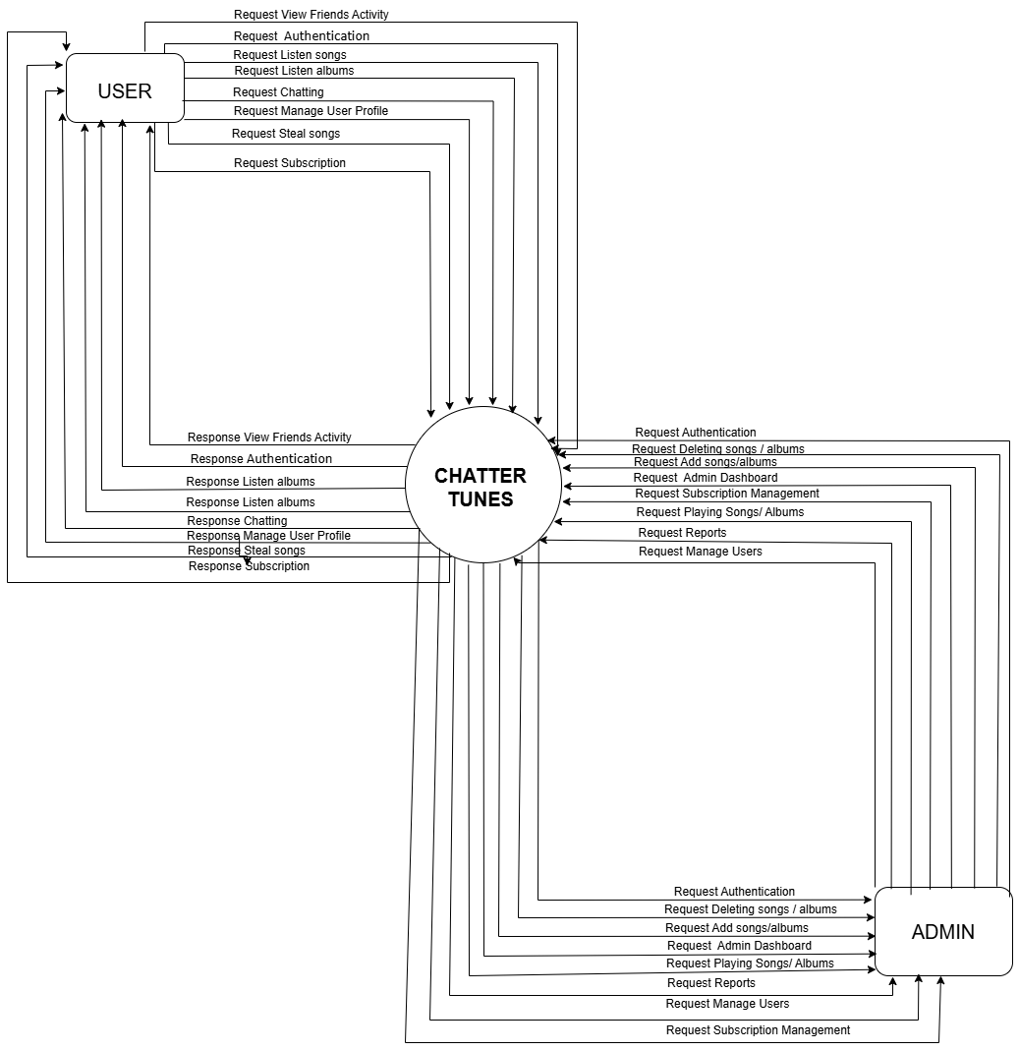

**Context (0) Level Data Flow Diagram – Audio Streaming Platform**

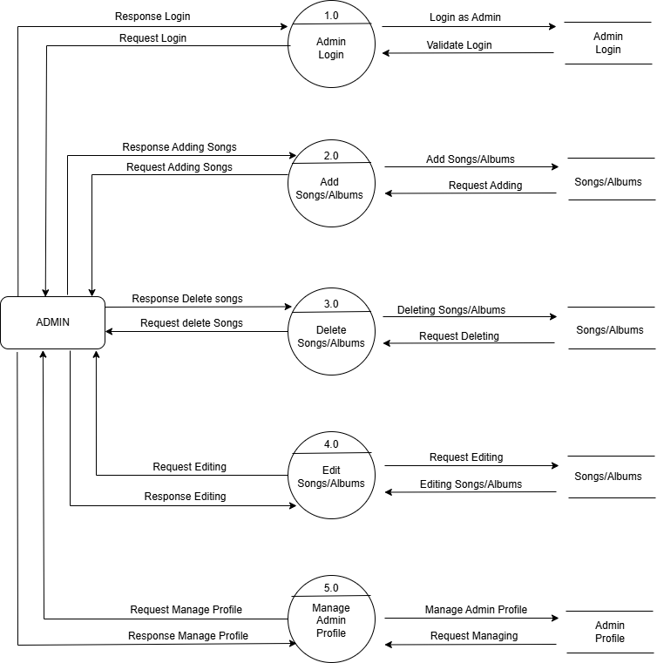

**First (1) Level Data Flow Diagram ( Admin Side ) – Audio Streaming Platform**

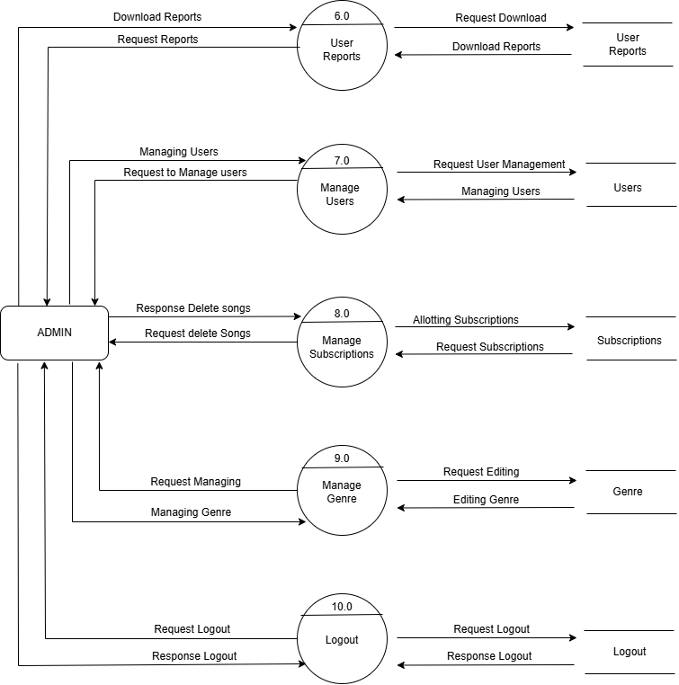

**First (1) Level Data Flow Diagram ( Admin Side ) – Audio Streaming Platform**

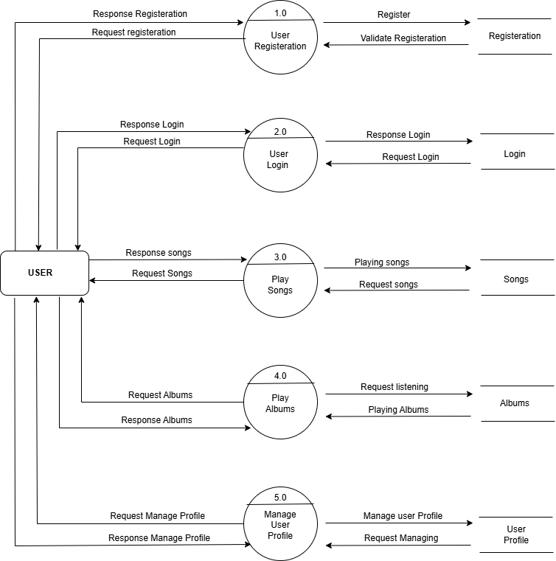

**First (1) Level Data Flow Diagram ( User Side ) – Audio Streaming Platform**

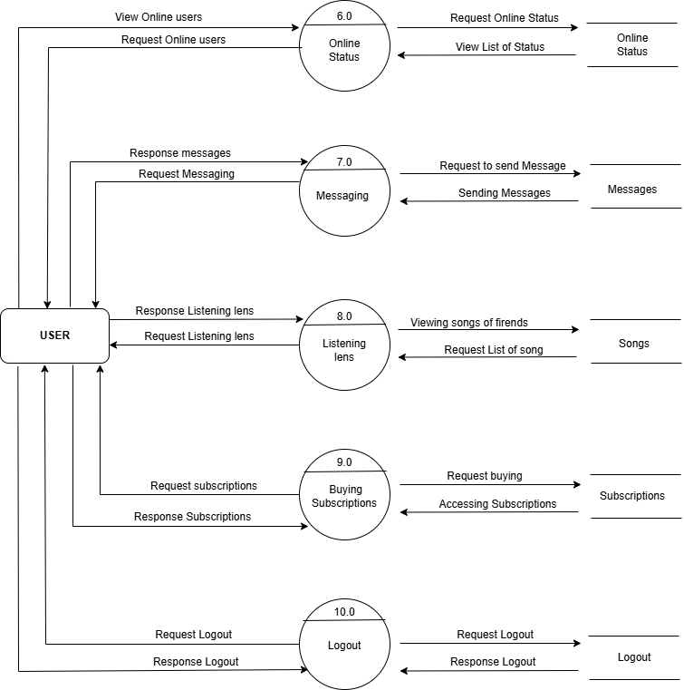

**First (1) Level Data Flow Diagram ( User Side ) – Audio Streaming Platform**

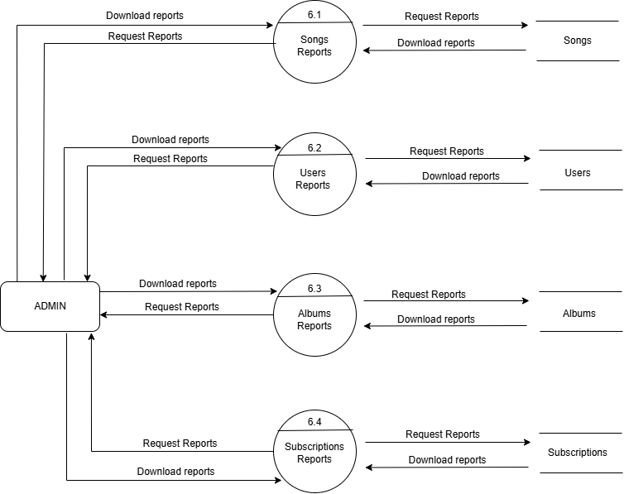

**Second (2) Level Data Flow Diagram ( Admin Side ) – Audio Streaming Platform**

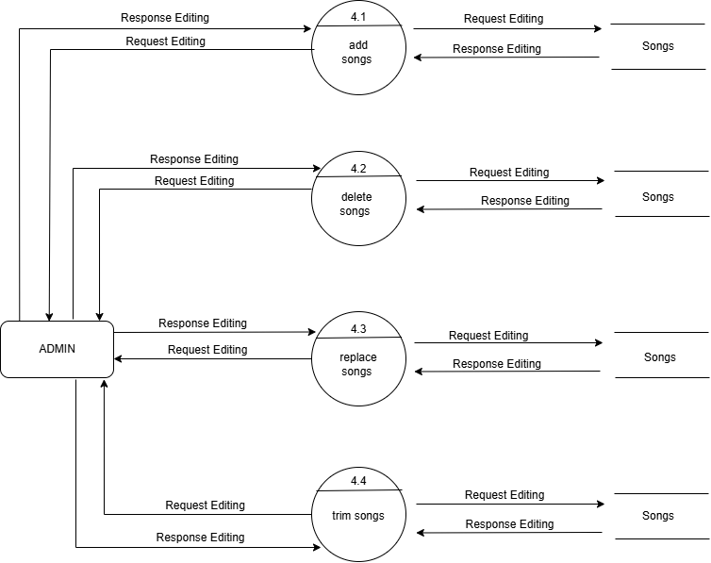

**Second (2) Level Data Flow Diagram ( Admin Side ) – Audio Streaming Platform**

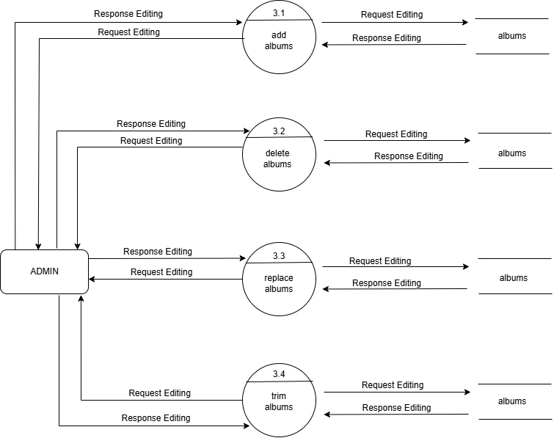

**Second (2) Level Data Flow Diagram ( Admin Side ) – Audio Streaming Platform**

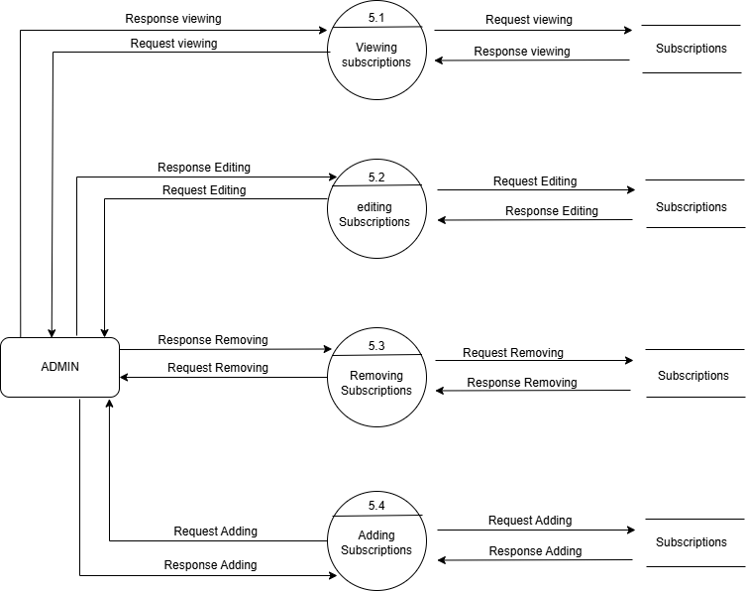

**Second (2) Level Data Flow Diagram ( Admin Side ) – Audio Streaming Platform**

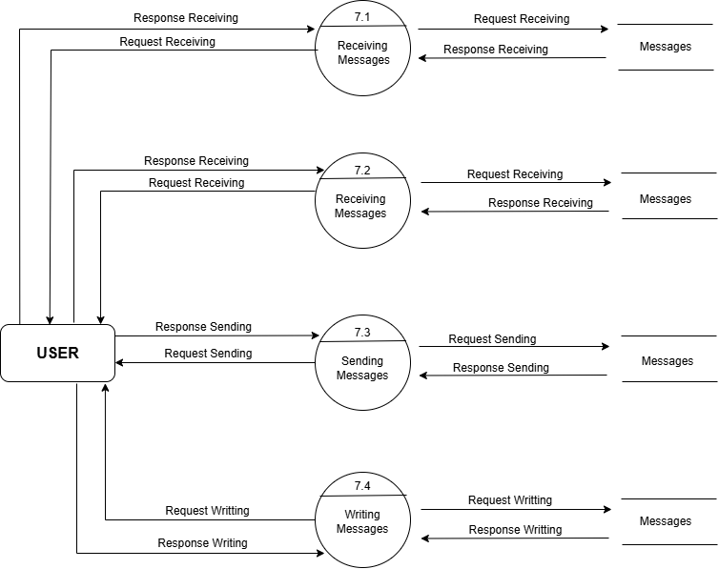

**Second (2) Level Data Flow Diagram ( User Side ) – Audio Streaming Platform**

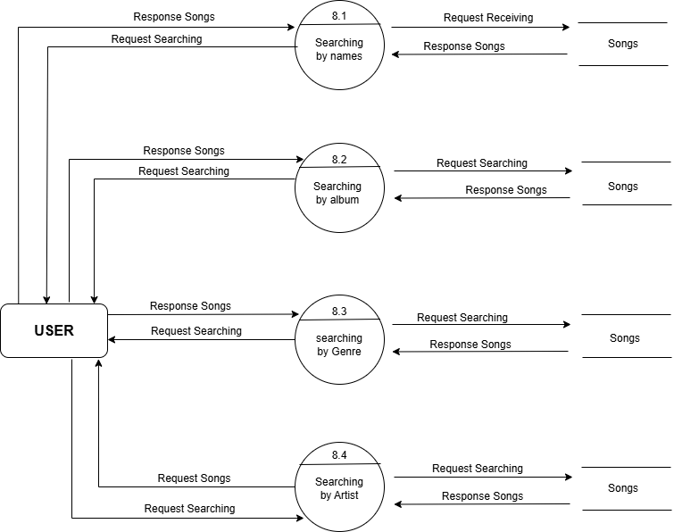

**Second (2) Level Data Flow Diagram ( User Side ) – Audio Streaming Platform**

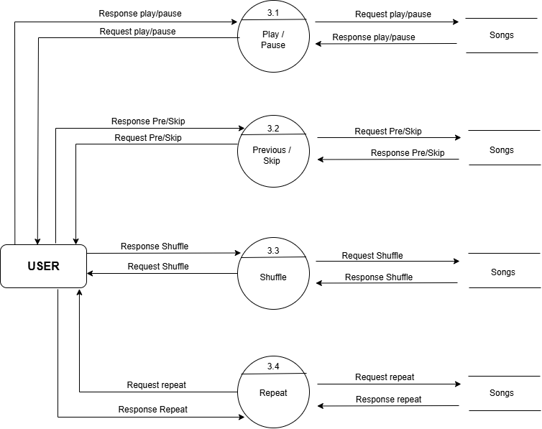

**Second (2) Level Data Flow Diagram ( User Side ) – Audio Streaming Platform**

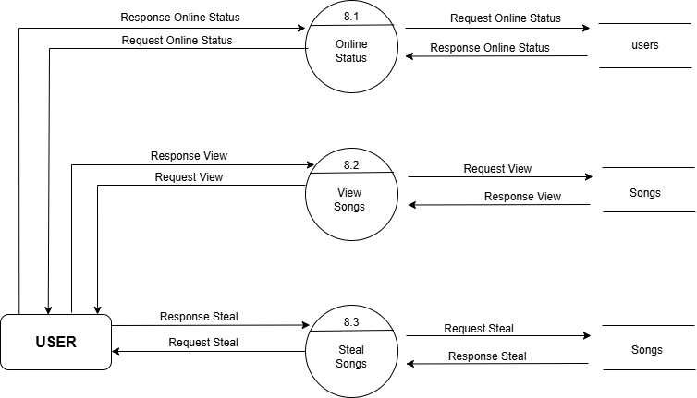

**Second (2) Level Data Flow Diagram ( User Side ) – Audio Streaming Platform**

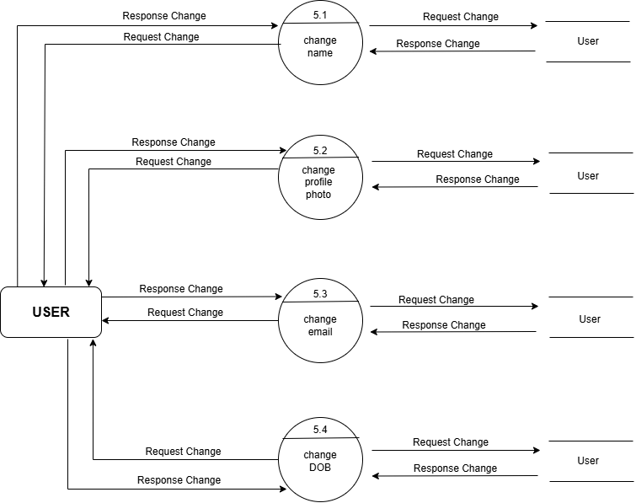

**Second (2) Level Data Flow Diagram ( User Side ) – Audio Streaming Platform**

**7.2 Process Specification**

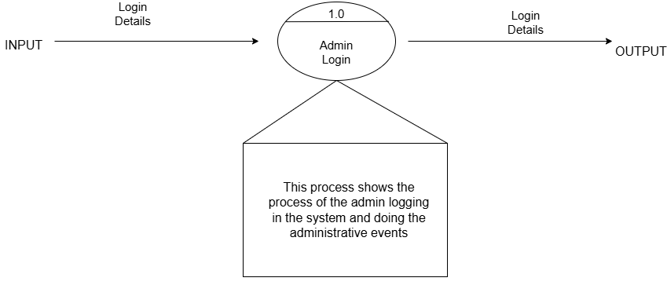

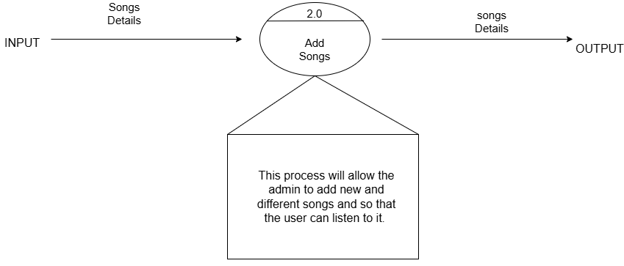

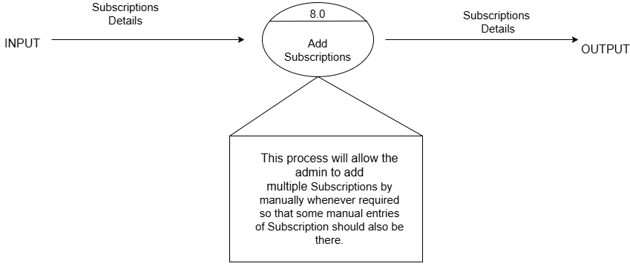

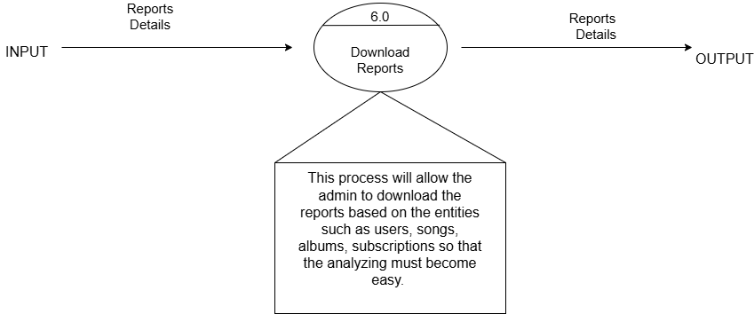

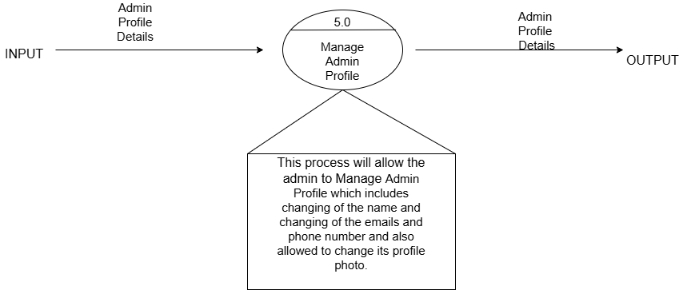

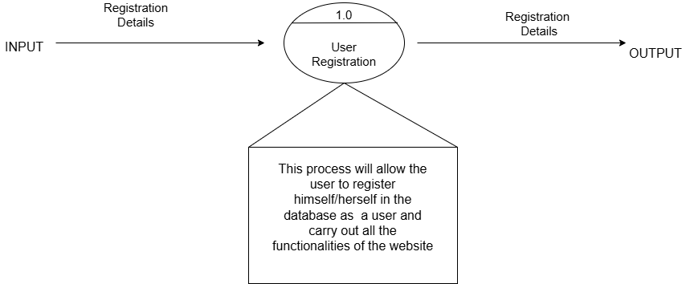

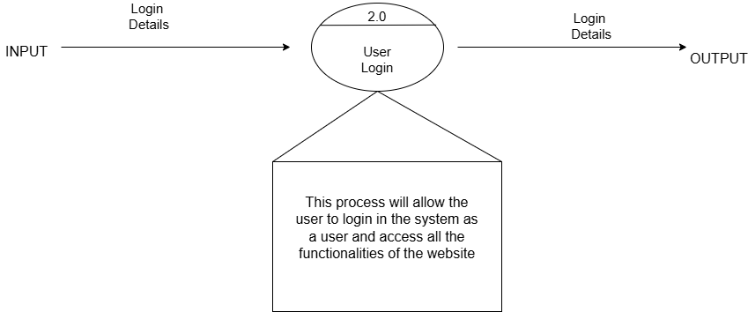

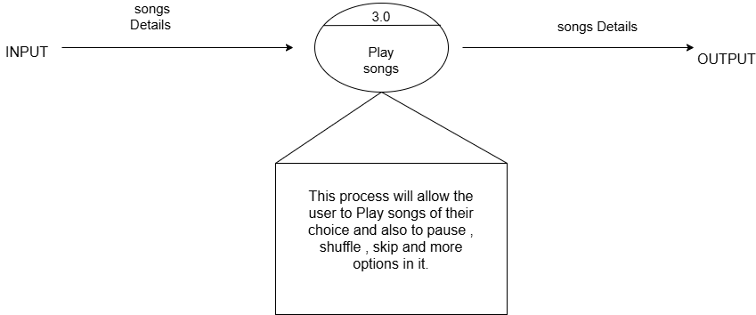

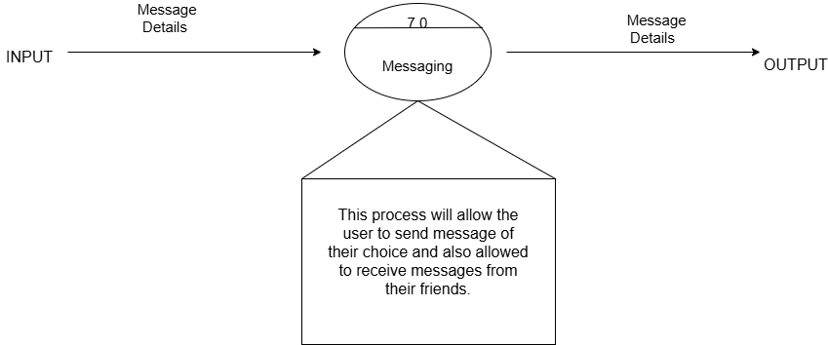

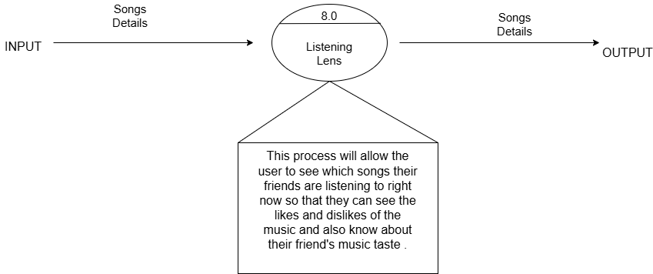

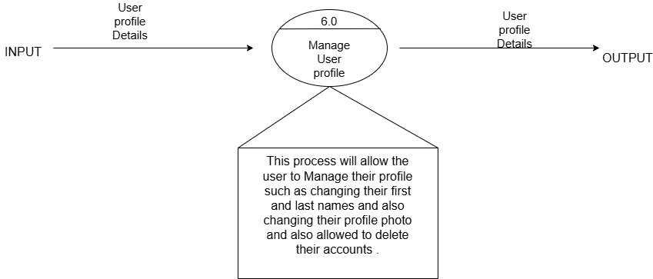

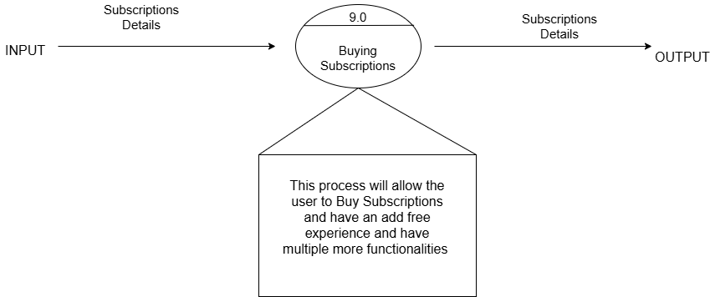

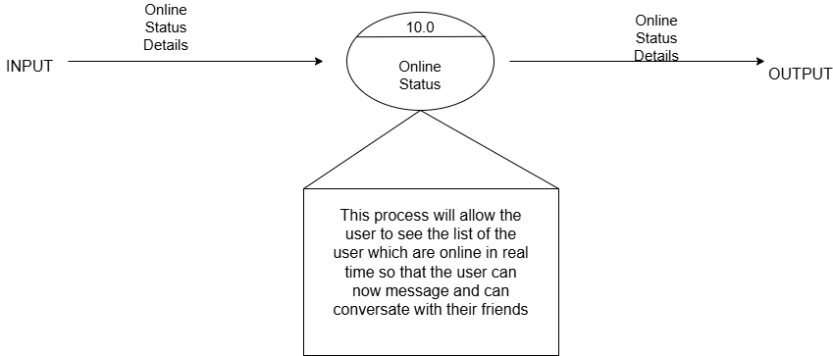

**7.3 Data Dictionary**

**[1] Songs Master Table: -**

|  |  |
| --- | --- |
| **Name** | Songs Details |
| **Alias name** | None |
| **Where And How Use?** | 1. Play songs (IN)   8.0 Listening Lens(IN / OUT) |
| **Description** | Song Id + Title + Artist + Image URL+ Audio URL + Created at + Updated at + Album Id |

**[2] Albums Master Table:-**

|  |  |
| --- | --- |
| **Name** | Albums Details |
| **Alias name** | None |
| **Where And How Use?** | 4.0 Play songs (IN)  8.0 Listening Lens(IN / OUT)) |
| **Description** | Albums with following fields  Title + Artist + Image + URL + Release year + Songs + Created at + Updated at |

**[3] User Master Table:-**

|  |  |
| --- | --- |
| **Name** | Users Details |
| **Alias name** | None |
| **Where And How Use?** | 5.0 Manage User profile (IN/OUT) |
| **Description** | Doctor login with following fields  ID + First name + Last Name + Image URL  Clerk Id + created at + Updated at  . |

**[4] Subscription Master Table:-**

|  |  |
| --- | --- |
| **Name** | Subscription Details |
| **Alias name** | None |
| **Where And How Use?** | 8.0 Manage Subscriptions ADMIN (IN/OUT)  9.0 Buy Subscriptions USER (IN/OUT) |
| **Description** | Subscription hadler Details:  ID + User Id + Price Id + Status + Created at |

**[5] Messages Master Table:-**

|  |  |
| --- | --- |
| **Name** | Messages Master Details |
| **Alias name** | None |
| **Where And How Use?** | 7.0 Messaging (IN/OUT) |
| **Description** | Messages Master Table Relation Details  Id + Sender Id + Receiver Id + Content + Created at + Updated at |

**[6] Artist Master Table:-**

|  |  |
| --- | --- |
| **Name** | Artist Master Details |
| **Alias name** | None |
| **Where And How Use?** | 2.0 Add Songs / Albums (IN) |
| **Description** | Artist Master Table Relation Details  ID + Name + Song Id + Album ID + Created at + Updated at |

**7.4 Table Structure**

**(1) Songs Master Table :-**

|  |  |  |  |
| --- | --- | --- | --- |
| **Attribute** | **Data Type** | **Constraint** | **Description** |
| Song Id | Integer | Primary Key | Indicate song  Id |
| Title | Varchar(25) | Not Null | Indicate song Name |
| Artist | Varchar(25) | Not Null | Indicate Artist name |
| Image URL | Varchar(25) | Not Null | Indicate image url of cover |
| Audio URL | Varchar(10) | Not Null | Indicate url of audio of the song |
| Created at | Varchar(30) | Not Null | Indicate time and date when the song created |
| Updated at | Varchar(30) | Not Null | Indicate time and date when the song  updated |
| Album Id | Integer | Foreign Key | The id number of the alum in which this song comes in. |

**(2) User Master Table :-**

|  |  |  |  |
| --- | --- | --- | --- |
| **Attribute** | **Data Type** | **Constraint** | **Description** |
| ID | Integer | Primary Key | Indicates the number of the Id of the user |
| First name | Varchar(25) | Not Null | Indicates the first name of the user |
| Last name | Varchar(25) | Not Null | Indicates the last name of the user |
| Image URL | Varchar(25) | Not Null | Indicates the URL of the profile photo of the user |
| Clerk Id | Integer | Not Null | Indicates the Id of the clerk ID |
| created at | Varchar(25) | Not Null | Indicates the date and time when the user is logged in |
| Updated at | Varchar(25) | Not Null | Indicates the date and time when the user is updated his profile |

**(3) Subscription Master Table :-**

|  |  |  |  |
| --- | --- | --- | --- |
| **Attribute** | **Data Type** | **Constraint** | **Description** |
| ID | Integer | Primary key | Indicates the Id number of the subscription. |
| User Id | Integer | Not Null | Indicates the user id of the user who is purchasing the subscription. |
| Price Id | Integer | Not Null | Indicates the price of the package if the subscription purchased. |
| Status | Varchar(25) | Not Null | Indicates the status of the subscription weather it is active or not.4 |
| Created at | Varchar(25) | Not Null | Indicates the date and time when the subscription is purchased. |

**(4) Albums Master Table :-**

|  |  |  |  |
| --- | --- | --- | --- |
| **Attribute** | **Data Type** | **Constraint** | **Description** |
| ID | Integer | Primary key | Indicates the Id number of the album |
| Title | Varchar(25) | Not Null | Indicates the name of the album |
| Artist | Varchar(25) | Not Null | Indicates the name of the artist |
| Image URL | Varchar(25) | Not Null | Indicate image url of cover |
| Release year | Integer | Not Null | Indicate the release year |
| Songs | Array | Not Null | Indicated the array of the number of songs present. |
| Created at | Varchar(25) | Not Null | Indicate time and date when the album created |
| Updated at | Varchar(25) | Not Null | Indicate time and date when the album updated. |

**(5) Messages Master Table :-**

|  |  |  |  |
| --- | --- | --- | --- |
| **Attribute** | **Data Type** | **Constraint** | **Description** |
| Id | Integer | Primary key | Indicates the Id number of the message |
| Sender Id | Integer | Not Null | Indicates the Id number of the sender |
| Receiver Id | Integer | Not Null | Indicates the Id number of the receiver |
| Content | Varchar(25) | Not Null | Indicates the main content of the message |
| Created at | Varchar(25) | Not Null | Indicate time and date when the message is created |
| Updated at | Varchar(25) | Not Null | Indicate time and date when the message is updated. |

**(6) Artist Master Table :-**

|  |  |  |  |
| --- | --- | --- | --- |
| **Attribute** | **Data Type** | **Constraint** | **Description** |
| ID | Integer | Primary key | Indicates the Id number of the Artist |
| Name | Varchar(25) | Not Null | Indicates the name of the message |
| Song Id | Integer | Foreign Key | Indicates the Id number of the song of this artist |
| Album ID | Integer | Foreign Key | Indicates the Id number of the album of this artist |
| Created at | Varchar(25) | Not Null | Indicate time and date when the artist is created |
| Updated at | Varchar(25) | Not Null | Indicate time and date when the artist is updated. |

**7.6 Site Diagram / Program Flow Diagram**

* **Admin :-**

* **User:-**

**7.7 Algorithm / Flow Chart**

* An Algorithm For the Admin login Process :-

Step 1: Start

Step 2: Enter Username and Password for Admin login.

Step 3: Read Username and Password from user input Textbox.

Step 4: If Username and Password matches with database

Admin Table.

Then

Admin can redirect to Admin dashboard screen

Else

View Error message

Step 5: Stop

* An Algorithm For the User login Process :-

Step 1: Start

Step 2: Enter Username and Password for User login.

Step 3: Read Username and Password from user input Textbox.

Step 4: If Username and Password matches with database User Table.

Then

Doctor can redirect to User dashboard screen

Else

View Error message

Step 5: Stop

* An Algorithm For the song playing Process :-

Step 1: Start

Step 2: Select a Song

The user selects a song from the available list (e.g., via a user interface control).

Step 3: Read the Song Identifier

Step 4: Query the Songs Table

If the query returns no record, display an error message: "Error: Song not found."

Step 5: Verify Song Availability

Check the available field in the retrieved record.

If the song is not available:

* + - Display an error message: "Error: Song is currently unavailable."

Else (if the song is available):

* + - Proceed to the next step.

Step 6: Update Streaming Analytics

Step 7: Open Streaming Connection

If unable to open the connection, display an error message: "Error: Unable to open the song stream."

Step 8: Stream the Song in Chunks

Step 9: Close the Streaming Connection

Once streaming is complete, close the connection to free up system resources.

Step 10: Stop

* An Algorithm For the adding a song as an Admin :-

Step 1: Start

Step 2: Authenticate the Admin and Navigate to the "Add Song" Page

Redirect the admin to the "Add New Song" interface.

Step 3: Input Song Details

Present the admin with a form to enter song information such as:

* + Song Title
  + Artist
  + File Path or URL

Ensure that required fields are clearly marked.

Step 4: Read the Song Details from the Admin Input

Retrieve the information entered by the admin from the form fields.

Step 5: Validate the Input Data

Step 7: Execute the Insert Statement Against the Database

Use the prepared SQL statement along with the validated input data.

Step 8: Confirm Insertion

If the record is inserted successfully, display a success message to the admin, such as: "Success: The song has been added to the database."

If the insertion fails, show an error message with details for debugging.

Step 9: End

* An Algorithm For seeing who are online :-

Step 1: Start

Step 2: Authenticate the Request

Validate that the admin or authorized user is logged in and has permission to view active user sessions.

Step 3: Connect to the Online Users Data Store

Access the store where online user activity is tracked (e.g., a user_sessions table or an in-memory cache).

Step 4: Query Active Sessions

Retrieve a list of users with recent activity.

Step 5: Verify and Process the Results

Check if the query returns any active sessions:

* + If no active sessions are found, prepare to display a message like “No users online right now.”
  + If active sessions are found, process and compile the list, optionally sorting or grouping by additional criteria (e.g., user role, subscription type).

Step 6: Display the Online Users List

Render the compiled list of online users on the admin dashboard or designated interface:

**7.9 Use Case Diagram**

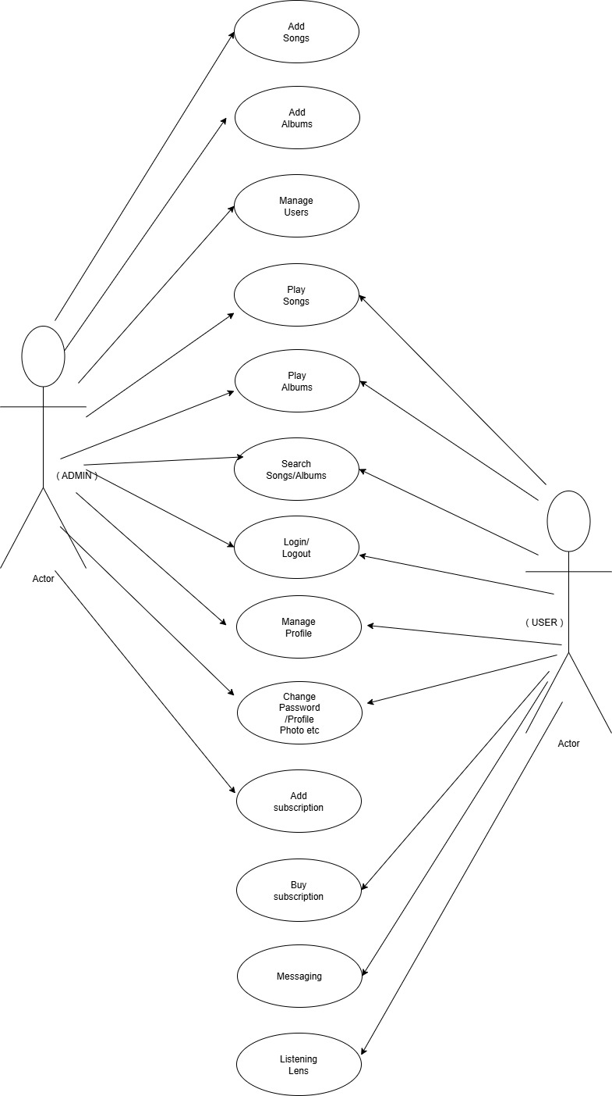

**8. Design Reports**



**8.1 Security Issues**

**8.2 Input Screen Layouts**

**8.1 Security Issues**

* **Unauthorized Access & Weak Authentication:** • Insufficient password policies and lack of multi-factor authentication risk unauthorized entry into both user and admin portals. • Poor session handling could lead to session hijacking or fixation.
* **Unencrypted Communication:** • Absence of SSL/TLS encryption may expose data—especially real-time messaging and payment details—to interception by malicious actors.
* **Input Validation Vulnerabilities:** • Inadequate sanitization of search fields, messaging inputs, and admin controls can open pathways for SQL injection, cross-site scripting (XSS), and other injection attacks. • Missing safeguards like CSRF tokens leave forms and API calls susceptible to cross-site request forgery.
* **Digital Piracy & Content Theft Risks:** • The “steal songs” functionality inherently poses legal risks by enabling unauthorized copying, potentially making the platform liable for copyright infringement.
* **Payment & Subscription Security Gaps:** • Insecure handling of financial transactions can expose users to fraud, and flaws in subscription management might allow for fraudulent exploits or unauthorized access to premium features.
* **Weak Role-Based Access Controls:** • Without clearly defined access layers, there’s a risk that normal users could access admin functionalities, increasing the potential for privilege escalation and data misuse.
* **API and Endpoint Vulnerabilities:** • Unsecured APIs for real-time functionalities, messaging, and data exchange may serve as entry points for attackers if not properly authenticated and rate-limited.

Each of these points highlights potential vulnerabilities that should be addressed to secure both the streaming functionality and the administrative controls. It is essential to implement robust security measures to safeguard user data, maintain legal compliance, and ensure operational integrity.

* 1. **Input Screen Layout**
* LOGIN PAGE :-

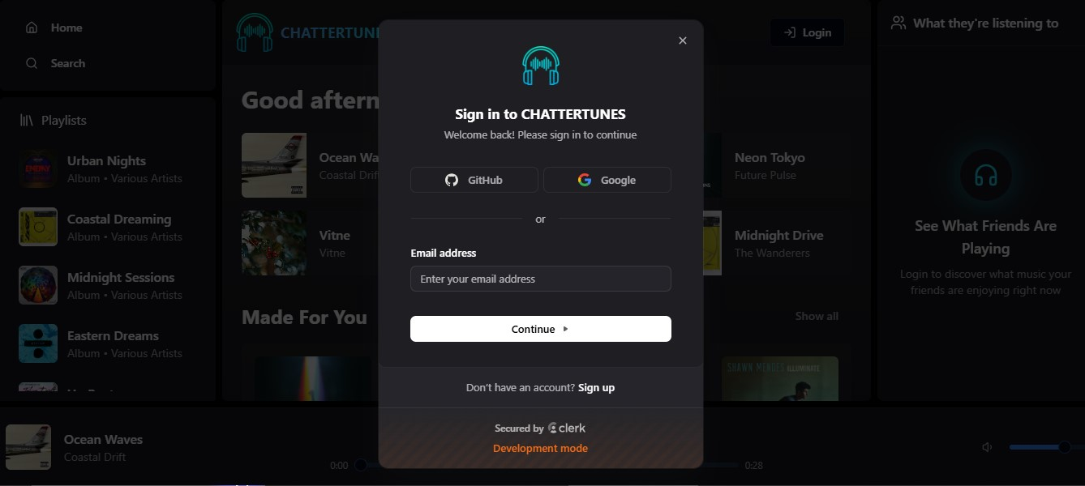

* REGISTERATION PAGE :-

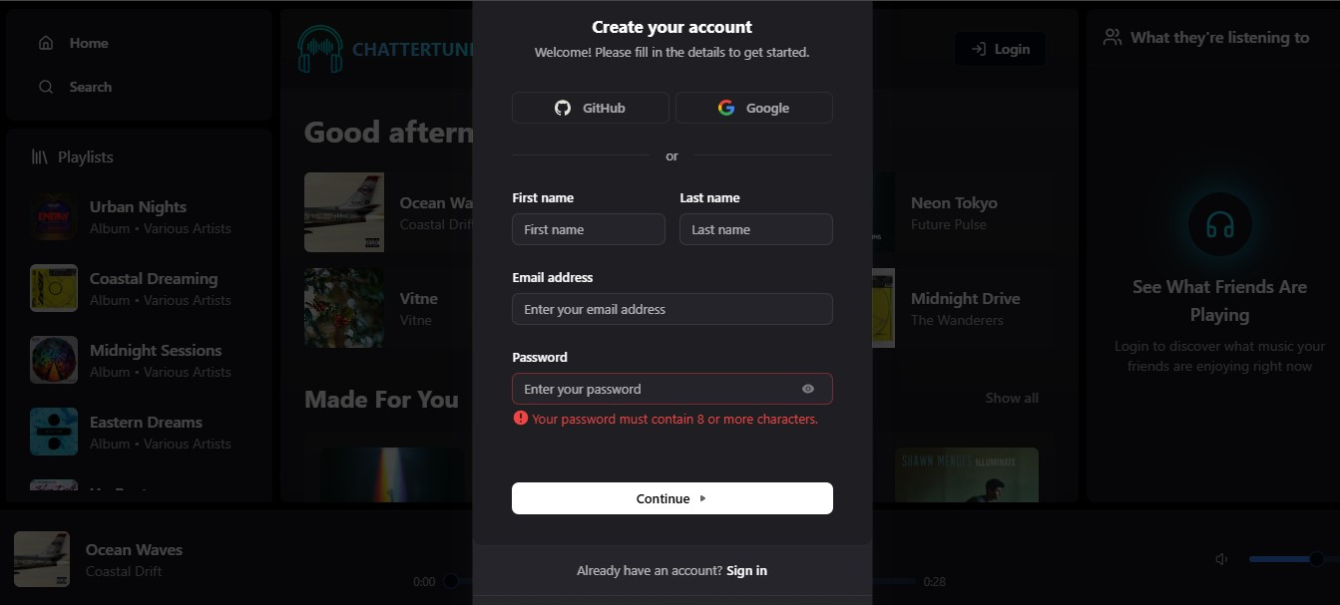

* HOME PAGE :-

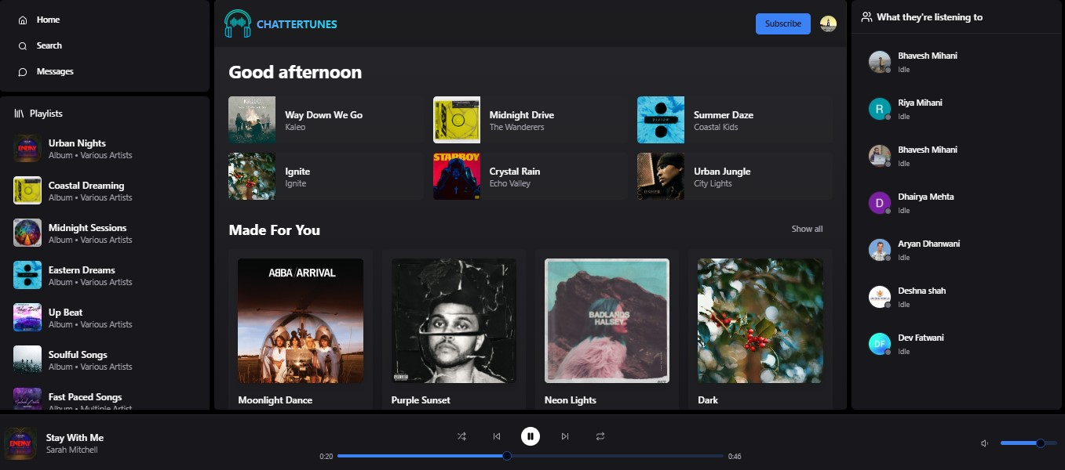

* ALBUMS PAGE :-

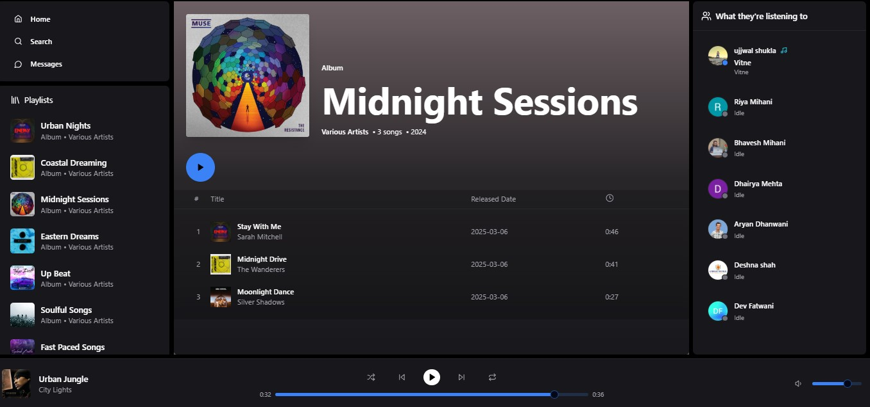

* LISTENING LENS PAGE :-

* MESSAGE PAGE :-

* USER PROFILE PAGE :-

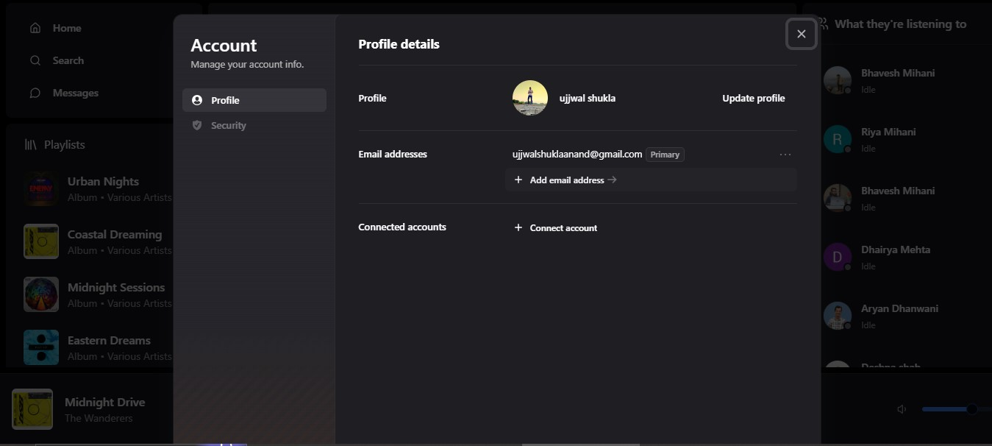

* SEARCHING SONGS PAGE :-

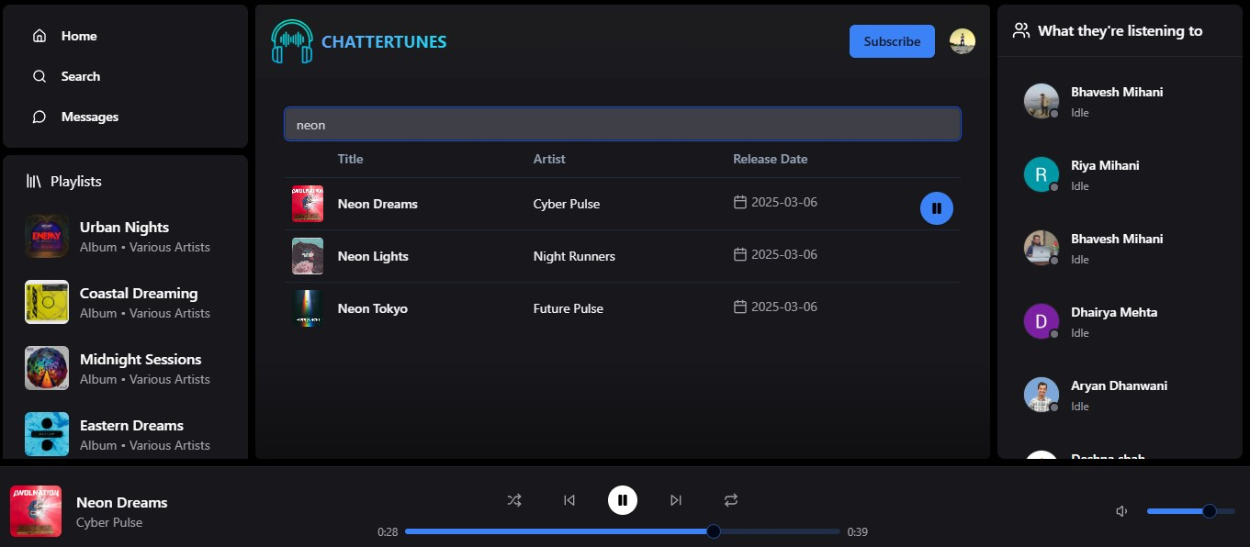

* SUBSCRIPTION PAGE :-

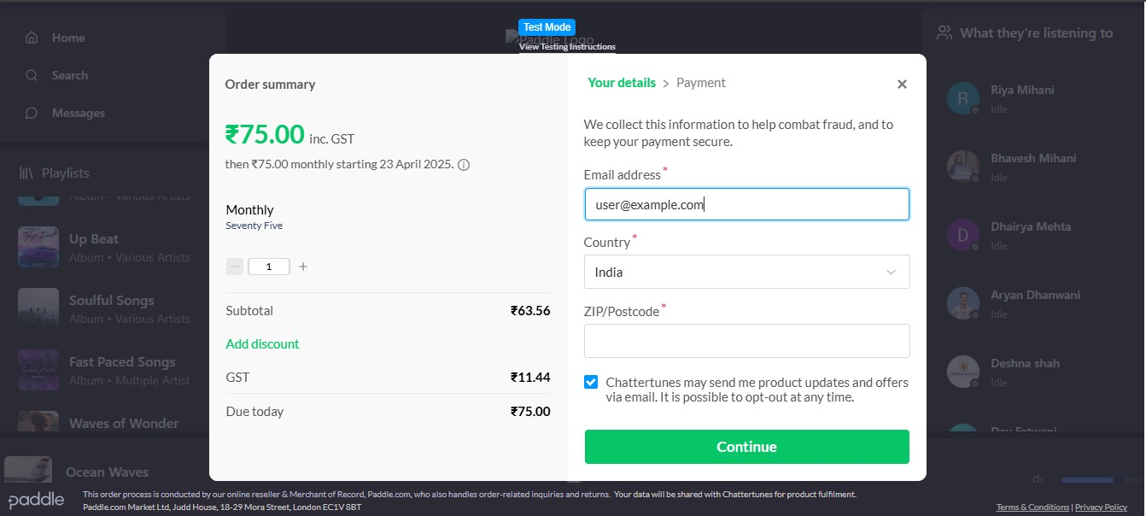

* ADMIN DASHBOARD PAGE :-

* ADMIN ALBUM VIEW PAGE :-

* ADMIN ADD SONG PAGE :-

* ADMIN ADD ALBUM PAGE :-

* ADMIN REPORT DOWNLOAD PAGE :-

* ADMIN PROFILE PAGE :-

**9. Testing Report**

**9.1 Testing Module**

**9.2 Test Case Design**

**9.3 Testing Issues**

**9.1 Testing Module**

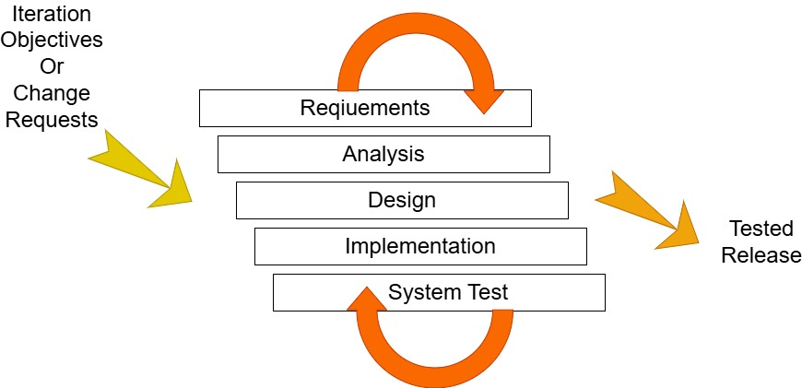

* Testing is the process carried out on software to detect the differences between its behaviour and desired behaviour as stipulated by the requirements specifications.
* Testing is advantageous in several ways. Firstly, the defects found help in the process of making software and reliable. Secondly, even if the defects found are not corrected, testing gives an idea as to how reliable the software is.
* Thirdly, over time, the record of defects found reveals the most common kinds of defects, which can be used for developing appropriated preventive measures such as training proper design and reviewing.

**9.2 Testing Case Design**

* **User Authentication & Session Management:** • Validate registration, login, and logout flows with both valid and invalid credentials. • Test session timeouts and password recovery functionalities.
* **Search Functionality:** • Verify search results for songs and albums using partial and full titles. • Test handling of non-existent keywords and special characters.
* **Streaming Playback & Buffering:** • Check audio streaming quality under various network conditions. • Validate error handling when streaming is interrupted or fails.
* **Real-Time Interactions:** • Ensure the online users list updates dynamically. • Test sending and receiving messages between users, including offline message queuing and notifications.
* **"Steal Songs" Feature:** • Evaluate the functionality for unauthorized copying (or content sharing) to confirm it behaves as intended, while flagging potential copyright irregularities.
* **Subscription & Payment Flow:** • Simulate the subscription purchase process, including handling successful and failed payment transactions. • Validate that the ad-free experience is activated upon completion of a valid subscription.
* **Admin Portal Functionalities:** • Test admin login with both valid and invalid credentials. • Verify CRUD operations (create, read, update, delete) for songs, albums, users, and subscriptions. • Ensure that admin-specific features (like profile updates and song playback) work seamlessly.
* **Performance & Security:** • Conduct load and concurrency tests to assess system behavior under high user activity.

• Run security cases to test for vulnerabilities and improper access across both user and admin portals.

Each of these points can be further broken into positive, negative, and edge scenarios to ensure comprehensive coverage of the system's behavior.

**9.3 Testing Issues**

* **Real-Time Data Sync Challenges:** Instances of delays and race conditions in updating online statuses and messages were observed.
* **Streaming & Buffering Fluctuations:** Variable network conditions led to intermittent buffering and quality degradation during song playback.
* **Security & Unauthorized Access:** The “steal songs” functionality raised red flags during testing, indicating potential for improper content access and copyright issues.
* **Payment & Subscription Workflow Bugs:** Simulated transactions revealed glitches in subscription activation, especially under load testing

.

* **Admin Portal Performance:** The admin side exhibited sluggishness during profile updates and data management, particularly with large datasets.
* **Cross-Platform Compatibility:** Inconsistencies in user interface behavior across different browsers and devices were detected.
* **Concurrency & Load Handling:** High simultaneous usage scenarios led to unexpected crashes and performance bottlenecks, emphasizing the need for enhanced load testing.

These issues form a solid foundation for further improvements, ensuring a more robust and secure system in future iterations.

**10. Limitation Of The**

**Proposed System**

**Limitation Of The Proposed System**

* **Legal & Ethical Concerns:** The ability for users to "steal songs" is ethically problematic and may lead to copyright infringement issues
* **Scalability Constraints:** Features such as real-time user tracking and messaging may struggle to cope with a rapidly growing user base and high concurrent loads.
* **Security Vulnerabilities:** With functionalities like messaging and live user status, there is an increased risk of data breaches and unauthorized account access if advanced security measures are not in place.
* **Limited Mobile Optimization:** The current design may not be fully responsive or offer a dedicated mobile app, reducing the quality of experience for users on mobile devices.
* **Basic Content Management:** The admin portal provides fundamental controls, but lacks advanced tools for robust content moderation, analytics, and library management as the platform scales.
* **Subscription & Payment Challenges:** Handling payments and subscriptions without comprehensive testing could lead to issues with recurring transactions and overall reliability.

These limitations outline areas for potential improvement and can serve as a foundation for planning future enhancements.

**11. Future Enhancement**

**11. Future Enhancement**

• **Mobile Platform Expansion:** Develop dedicated mobile apps for iOS and Android to improve accessibility and user engagement on the go.

• **AI-Driven Recommendations:** Integrate machine learning for personalized playlists, improved search results, and intelligent content suggestions.

• **Enhanced Social Features:** Expand social interaction with features like group playlists, collaborative listening rooms, and moderated sharing—ensuring user content rights are respected.

• **Offline Playback:** Enable users to download songs or albums for offline listening, enhancing user experience in low-connectivity scenarios.

• **Advanced Analytics & Reporting:** Introduce detailed dashboards for both users and admins to monitor real-time streaming data, user engagement, and subscription trends.

• **Improved Security & Copyright Management:** Strengthen DRM measures, secure messaging, and payment systems, while refining the “song sharing” features to avoid potential content misuse.

• **Live Streaming & Events:** Add live streaming capabilities such as virtual concerts or artist-hosted sessions with integrated chat and real-time feedback

.

• **Multi-Language & Accessibility Upgrades:** Support diverse languages and include accessibility features to serve a broader, global audience.

**12. References**

**References**

* https://www.geeksforgeeks.org/create-and-add-data-to-firebase-firestore-in-android/
* https://stackoverflow.com/questions/59185036/how-to-connect-multiple-apps-to-firestore-database
* https://stackoverflow.com/questions/50032569/firestore-chat-app-using-firebase-ui-android
* https://stackoverflow.com/questions/68104622/android-create-a-new-user-in-firebase-authentication-but-with-data-from-firebase
* https://stackoverflow.com/questions/37352884/save-base64-encoded-image-to-firebase-storage
* https://www.geeksforgeeks.org/how-to-encode-and-decode-image-in-base64-in-android/
* https://www.geeksforgeeks.org/how-to-read-data-from-firebase-firestore-in-android/
* <https://guides.codepath.com/android/using-the-recyclerview>
* https://github.com/features/copilot